**Literacy** 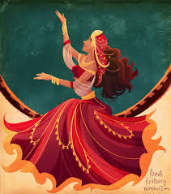

(Based on “Tales of Arabian Nights” and “War Game”)

* Narrative – eg: story writing, diaries, character and setting
* Non-fiction writing – eg: letters, information texts

**Skills**

* Use of a wider range of punctuation
* Use of grammar
* Comprehension skills

**Mathematics**

**(Following White Rose Planning)**

* Number – place value
* Number – addition, subtraction, multiplication and division
* Fractions
* Times tables
* Maths Challenges

 

**P.E.**

* Games skills – invasion games
* Gymnastics

**Art and Design**

* Describe some features and styles of Islamic art.
* Designs and Inventions

**French**

* Building Up Descriptions
* School Subjects

**Science** 

* The Nature Library (Classification; explain how the work of the early Islamic doctors impacted on modern medicine)
* Light Up Your World
* Everything Changes (States etc)

**Project-based Learning– Islamic Civilisation and World War 1**

* Say who Muhammad was
* Know some key facts about Baghdad
* Understand some of the developments in farming
* Understand that WW1 was a key turning point in History

**Computing**

* We are Planners
* We are Project Managers

**RE and PHSCE**

* How do Muslims show commitment to God?
* What do You Really Know About Christmas?

**Music**

* Take Ten Pieces – composing and performing (Purcell)

**Year 6 Autumn Term 2018**

1. **Tales of Arabian Nights**
2. **Everything Changes**

All plans are subject to some variation

