|  |
| --- |
| **What to know more?**  Should you wish to discuss our School Development Plan or have any questions, please contact the office or speak to your class teacher. |

**School Development Plan Priorities 2025-27**

**Information Leaflet for Families**

**What is a School Development Plan?**

A School Development Plan (SDP) is a strategic plan for improvement. It brings together in a clear, simple way, the priorities, actions and measures the school will take to raise standards. It details the targets the school intends to achieve and the resources needed.

**What is Bledlow Ridge School seeking to achieve?**

For pupils at Bledlow Ridge School to embody their School Values

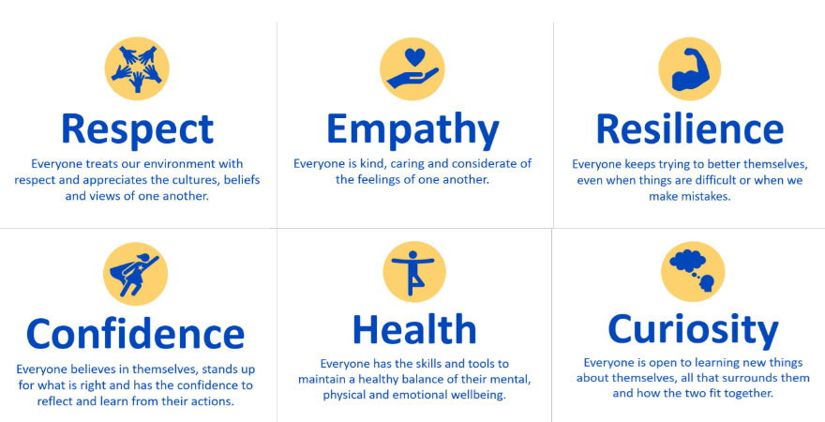

This leaflet will support our families understand what our SDP priorities are.

**School Development Plan Priorities 2025-2027**

**Priority 1: Writing and Handwriting**

To fully embed the Kinetic Letters handwriting scheme throughout the school, ensuring a consistent approach that leads to improved handwriting quality, greater pupil confidence, and increased enjoyment and engagement in writing.

**Priority 2: Maths**

To strengthen mathematical learning and enjoyment by working with local schools through the Maths Hub to organise competitions and enrichment events, while embedding consistent use of mathematical vocabulary and structured talk in lessons so pupils can confidently explain and justify their thinking. Teachers will continue to use adaptive teaching strategies to ensure all pupils make strong progress.

**Priority 3: IT and computing curriculum**

To continue delivering a successful and engaging Computing curriculum across KS1 and KS2, ensuring that pupils enjoy and remain motivated in the subject. Teachers will be supported to deliver lessons confidently with appropriate resources, and both staff and pupils will begin to use SharePoint to access and share resources across the curriculum.

**Priority 4: Personal Development and Wellbeing across the school (linked to school culture and building relationships)**

To ensure pupils develop a strong awareness of how to look after their physical and mental health, while continuing to prioritise and embed a whole-school culture that promotes health and wellbeing for both pupils and staff

**Priority 5: Travel Plan**

To develop a safe, sustainable, and inclusive school travel culture that reduces congestion, improves road safety, and encourages healthy lifestyles, while working towards achieving external recognition through the Modeshift STARS Bronze Award.

**Priority 6: Safeguarding**

To maintain and further strengthen the school’s outstanding safeguarding culture so that all children continue to feel safe, supported, and valued.

**Priority 7: Teaching and the curriculum**

To ensure every pupil—particularly those who are disadvantaged—can fully access the school’s ambitious curriculum through consistently excellent adaptive teaching. This will be informed by Challenge Bucks priorities and guided by evidence from the Education Endowment Foundation (EEF), reflecting our core principles: **ENGAGE – UNITE – REFLECT.**

**Priority 8: Inclusion**

The school demonstrates an excellent understanding of each pupil’s individual barriers to learning and addresses them promptly and effectively. Teachers meet the needs of disadvantaged pupils, including those with SEND, and adapt their teaching so that all pupils benefit from consistently high expectations.