BLEDLOW RIDGE SCHOOL
RELATIONSHIP POLICY

Policy date: March 2021 Review Date: July 2021

School ethos

Our aims at Bledlow Ridge School are threefold:
- To enable every child to reach his or her potential physically, emotionally, intellectually and socially;
- To ensure that each child feels included, valued and secure, and is able to recognise and appreciate his/her own worth and the worth of others;
- To encourage the children to become self-motivated and confident, and to acquire the skills and attitudes necessary for them to become independent, life-long learners.

With this in mind, our Relationship Policy has been written to reflect our aims throughout.

At Bledlow Ridge Primary school we are committed to providing a holistic approach to education which aims to support the academic, cultural, personal and social development of all our pupils. From September 2020 statutory Relationships Education and Health Education will be part of the taught curriculum within PSHE. This is an essential part of a child’s education and contributes to their personal development.

Aims of the Relationships policy
All state funded primary schools are required to teach Relationships Education and to have a Relationships Education policy by September 2020
The aim of this policy is to
- Provide information to staff, parents and carers, governors, pupils and other agencies regarding the organisation, content and approach to teaching Relationships Education
- Help parents and carers to understand Relationships Education and support them to work with their child to secure the very best outcomes for all pupils
- Demonstrate how the school meets legal requirements with regards to teaching Relationships Education
Legal Requirements
To comply with The Relationships Education, Relationships and Sex Education and Health Education (England) Regulations 2019, made under sections 34 and 35 of the Children and Social Work Act 2017, make Relationships Education compulsory for all pupils receiving primary education. They also make Health Education compulsory in all schools except independent schools.

To comply with the Relationships Education, Relationships and Sex Education (RSE) and Health Education statutory guidance from the DfE (June 2019)

To comply with the requirements to have an up to date Relationships policy developed in consultation with pupils, parents and carers (Education Act 1996) and in line with the DfE statutory guidance on Relationships Education, RSE and Health Education (June 2019)

To have due regard to the Equality Act (2010) which requires schools to prevent discrimination, advance equality of opportunity and foster good relation between different groups. The protected characteristics that apply to school age children are disability, race, religion or belief, sex, sexual orientation, gender reassignment, pregnancy and maternity.

To fulfil statutory safeguarding duties and ensure any safeguarding issues arising from Relationships teaching are identified and followed in accordance with the school safeguarding policy

At Bledlow Ridge Primary school we teach Sex Education as part of our Relationships and PSHE curriculum. As Sex Education is not statutory at primary we wish to state the right of parents and carers to withdraw their child from designated Sex Education lessons. (Please see Sex Education Policy)

Development of the policy
This policy was developed by the PSHE lead in consultation with school governors, and parent focus group and pupils which has been outlined at the end of this document.

This policy links to the PSHE policy, Sex Education Policy, Child Protection Policy, Anti-Bullying Policy, Equalities policy and the School Behaviour policy.
Statutory Relationships Education is taught through the Personal, Social, Health and Economic Education (PSHE) curriculum. The personal, social, health and economic development of our pupils is a vital element of education and we aim to work collaboratively with parents/ carers to ensure our children are well informed and supported to make healthy, safe and positive choices in all aspects of their daily lives. We welcome parents and carers to make an appointment to come in to discuss any aspect of this policy and the provision in school.

Definition of Relationships Education
Statutory Relationships at Bledlow Ridge Primary school is taught through the PSHE curriculum and teaches pupils what they need to know by the end of year 6 as defined by the DfE guidance. (See appendix 1) Relationships Education gives pupils the information they need to help them develop healthy, nurturing relationships with other children and adults. It should enable them to know what a healthy relationship looks like, how to build and maintain happy, healthy relationships with others and recognise the importance of a range of relationships with friends, family, in school and in wider community in which they live. Relationships Education also teaches pupils to recognise unhealthy behaviours, how to keep safe, identify potential dangers in their on and off line lives and how to report any concerns or abuse and where to access help when needed.

The Curriculum
Intent - Why teach Relationships Education?
Relationships Education will become statutory from September 2020. High quality Relationships Education will support pupils to :
- Form and maintain positive relationships with other children and adults
- Understand the importance of positive and healthy relationships on their wellbeing
- Recognise what makes a good friendship and how to be a good friend in return
- Strategies to manage the ups and downs of friendships and relationships with others
- Show respect for others and recognise diversity within relationships, treating each other with kindness, consideration and understanding
- Develop positive character traits and personal attributes such as self- respect, kindness, honesty, integrity and resilience
- Positively engage in social action and contribute to the wellbeing of others
- Understand the principles of positive relationships also apply on line, how to keep safe and how to report concerns
- Understand the importance of recognising and establishing their own personal boundaries and privacy
- Understand and respect differences and combat all forms of bullying and discrimination
- Recognise unhealthy relationships, inappropriate behaviour and bullying and to report concerns or abuse and are taught the appropriate vocabulary to do so (including signposting to trusted online support services such as Childline)
- Ask a trusted adult rather than go on line with regards to any concerns about relationship issues and avoid viewing any inappropriate material or entering into social media conversations that can could cause them harm
- Recognise intimate physical relationships are for adults
Implementation
Relationships Education is delivered through the PSHE curriculum. These aspects of the Relationships Education as defined by the DfE will be taught at an age appropriate level. Further details can be found in appendix 1.

To ensure the content and delivery of relationships education is appropriate and relevant to our pupils we use simple baselines to ascertain what pupils already know, and find out what they would like to learn.
Distancing techniques are used to teach relationships education, which provides depersonalised examples which support children to explore what, is being taught without sharing their own personal experiences in the lesson.
We provide an inclusive curriculum that promotes understanding and mutual respect for all. We reflect diversity within our curriculum to ensure that no pupil feels excluded and teach pupils to respect difference, promote equality and challenge stigma.
Outcomes for Relationships Education are defined by the DfE and cover:

- Families and people who care for me
- Caring friendships
- Respectful relationships
- On line relationships
- Being safe

What we use – High quality assured resources provided from the PSHE Association programme of study, Twinkl, SEAL and online teaching.

Who – Relationships education starts in Reception and is taught by all teachers until the end of year 6.

When – PSHE lessons are 30 - 50 minutes per week, covered with-in topics and during Time To Talk Days

How delivery and content will be made accessible to all pupils including SEND – This will be differentiated on a case by case teacher led decision, depending upon the specific needs of the child in question. These lessons may be but not exclusively be either 1-1 lessons incorporated into games or stories in order to make them accessible to the child. The child may be in the class with the other students or out of class on a 1-1 basis.

Where you can view curriculum information – please see appendix 2 (year by year overview of the PSHE relationship provision is referred to as R -statements such as R1-R20).
Managing Difficult Questions – All aspects of PSHE are underpinned by shared and understood ground rules (these have been created by staff and checked over by the children - Appendix 3) with lessons being delivered in a safe and well managed environment. Pupils are encouraged to ask questions and raise issues in a respectful and appropriate manner. Some questions or issues raised may not be appropriately answered in whole class lessons and these will be followed up separately on an individual or group basis. A question box or worry monster is available for pupils who do not feel confident to ask questions or wish to have a separate conversation with a member of staff. Given ease of access to the internet, children whose questions go unanswered may turn to inappropriate sources of information.
Whilst it is vital to have trust and openness we cannot offer total confidentially to pupils. Any disclosures or areas of concern will be followed up in accordance with our safeguarding procedures. We also respect that some questions are better addressed at home with parents/ carers and the school will share information with parents/carers on an individual basis should the need arise.

Impact
High quality Relationships Education will enable our pupils to:
- Enjoy healthy and positive relationships with others
- Understand how their behaviour affects others and visa versa
- Value and understand the importance of maintaining good relationships
- Make positive choices about how they cultivate and nurture friendships and relationships
- Be aware of and respect different types of relationships in accordance with the Equalities Act
- Become actively engaged young citizens who make positive contributions to their families, the school and the communities to which they belong
- Recognise unhealthy relationships and have strategies to challenge negative behaviours
- Know what to do if there are problems within relationships both on and off line, how to keep safe and where to go to seek help

Confidentiality and safeguarding
Any personal disclosures made by pupils will be followed up in accordance with the school’s child protection policy. Teachers will report any safeguarding concerns to the DLS and share concerns with parents/carers according to the school’s safeguarding procedures.

Roles and Responsibilities
It is the statutory responsibility of the governing body to ensure the school has a compliant and up to date Relationships policy. The Governing Body are required to approve the policy and hold the Headteacher to account for its implementation.
The Headteacher is responsible for ensuring PSHE is taught consistently across the school and for managing requests with regards to the parental right to withdraw from non-statutory Sex Education.
The PSHE lead is responsible for leading and managing PSHE which includes statutory Relationships Education. Teachers are responsible for delivering PSHE.
Pupils are expected to fully engage with PSHE provision and treat other with respect.

Working with outside agencies and visiting speakers
We currently do not work with any outside agencies or visiting speakers for any aspect of our Sex Education curriculum content.

Monitoring, evaluation and training
PSHE provision will be monitored and evaluated by the PSHE lead, SLT and Governors in line with the monitoring cycle agreed by the school. The PSHE policy will be reviewed annually.

To ensure staff are confident to deliver all aspects of the PSHE curriculum access to online, in school, local and national training will be made available and in accordance with the school’s CPD programme for staff development.

Working with parents and carers (consulting, informing and supporting)
Parents and cares are only entitled to withdraw their child from designated sex education lessons. Parents and carers do not have the right to withdraw their child from PSHE which includes statutory Relationships Education and Health Education (including the changing adolescent body/puberty). The science curriculum also includes content on human development, including reproduction, which there is no right to withdraw from. We highly recommend all students receive the full PSHE curriculum.

Appendix 1 DfE descriptors
https://www.gov.uk/government/publications/relationships-education-relationships-and-sex-education-rse-and-health-education/relationships-education-primary

Appendix 2
PSHE Curriculum overview – Safeguarding concerns and safe relationships is covered in more detail in the Sex Education Policy
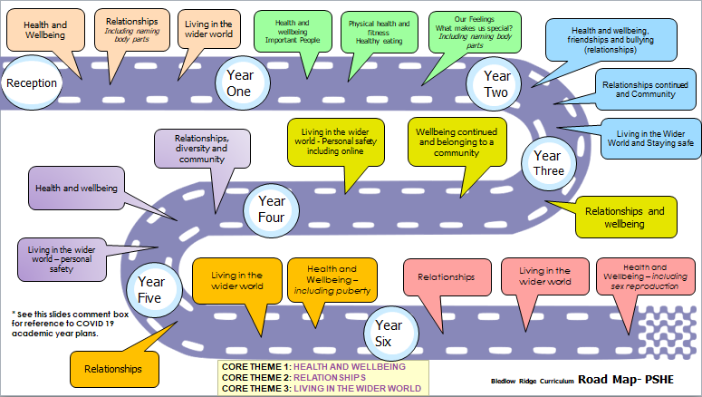
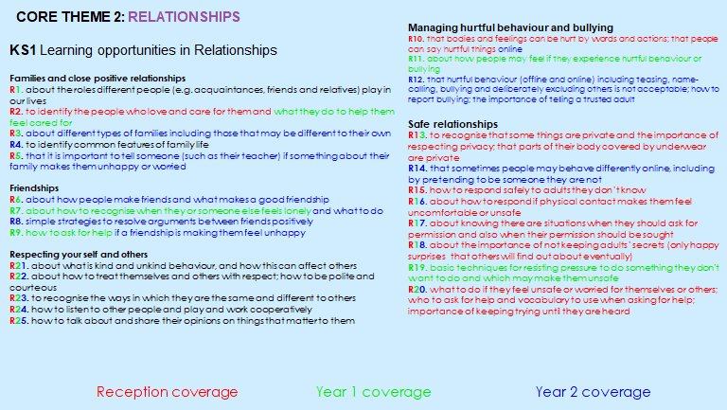

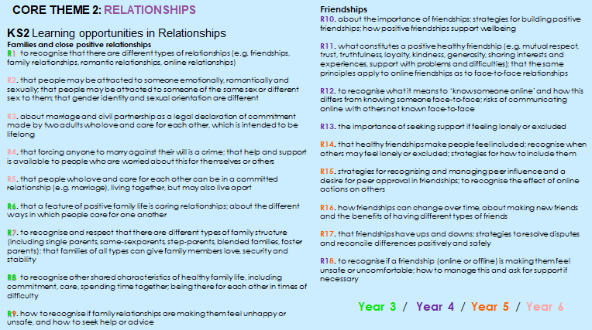

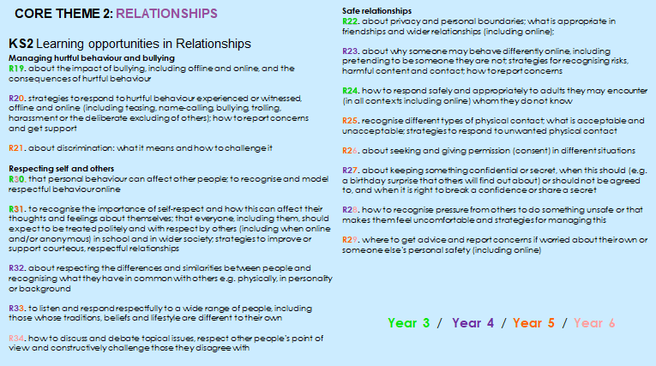

Appendix 3. Class ground rules
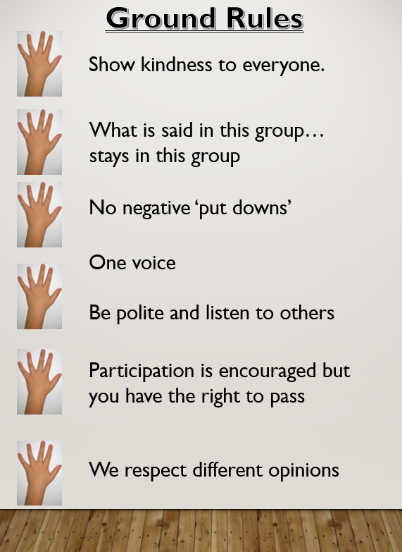

Appendix 4 – DFE guide for parents
https://assets.publishing.service.gov.uk/government/uploads/system/uploads/attachment_data/file/812593/RSE_primary_schools_guide_for_parents.pdf

Policy development
This policy was developed by the PSHE lead in consultation with staff, school governors and then a readability focus group of parents, governors and staff members.

Suggestions for policy development were:
- This policy has been updated with more reference to the stator rights about withdrawal and additional information has linked to the government guidance related to withdrawal in this document and on the school PSHE website link listed for parents to help clarify parent’s options.

Miss Claire West – PSHE lead with staff or working group pulled together all relevant information including relevant national and local guidance / guidance from Public Health PSHE lead.

Staff consultation – all school staff were given the opportunity to look at the policy and make recommendations.

Parent/stakeholder consultation – parents and any interested parties were invited to read thorough the final drafted version of the policy and feedback on any questions or queries that they had. The school has an open door policy that allows parents the opportunity to ask questions about our policies at any point in during the school year.

Pupil consultation – Miss West (PSHE Lead) or Mr. Gage (PSHE Governor) have and will continue to seek regarding PSHE lessons and questions raised to shape further lessons. This has been and may in future be achieved through a small focus group who can then give their consent to review or answer a questionnaire in class. In addition to these meetings, throughout the year, teachers will also be completing a reflective assessment of each terms targets and provide children with the opportunity to review each topic unit once completed.

Ratification – this policy was shared and ratified with governors.

This policy was created with the support of Carol Stottor (PSHE Lead for Public Health BCC).

