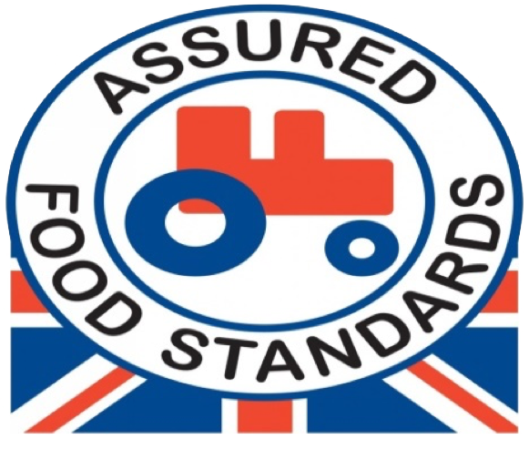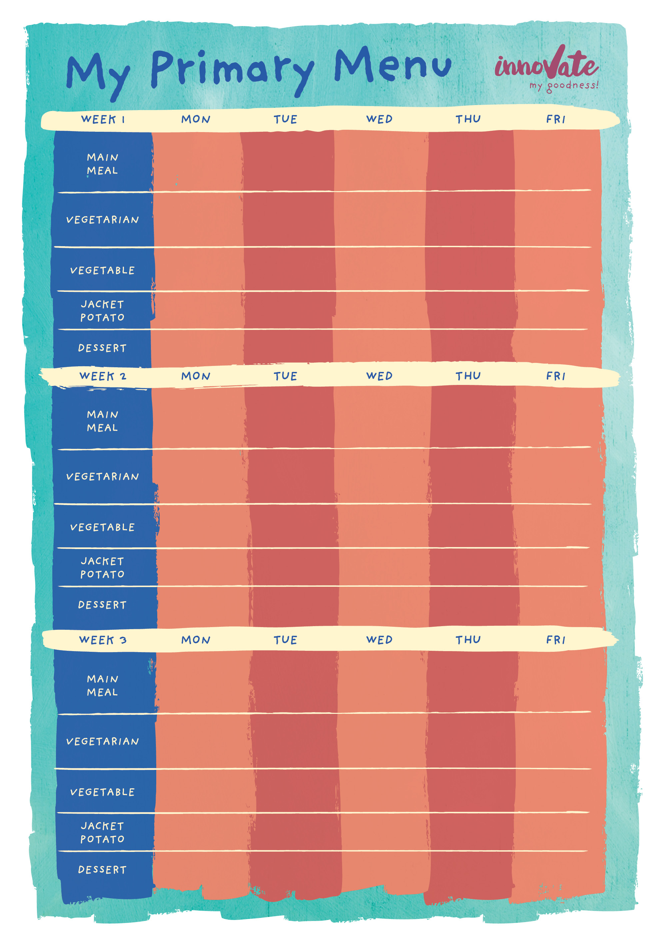=

Chocolate Sponge

Seasonal Fresh Fruit Pot

Chocolate Cookie

Seasonal Fresh Fruit Pot

Fruit Flapjack Slice

A Choice of Two Fillings

A Choice of Two Fillings

A Choice of Two Fillings

A Choice of Two Fillings

A Choice of Two Fillings

Baked Beans

Broccoli & Carrots

Garden Peas

Sweetcorn & Garden Peas

Broccoli & Cauliflower Cheese Bake

Pasta Twists served in a Herby Tomato Sauce

Roasted Vegetable Pasta Bake

Quorn & Spinach Korma served with Rice

Quorn Cottage Pie served with Gravy

Beef pasta Bolognese

Roast Chicken served with Roast Potatoes & Gravy

Sausage in Gravy served with Potatoes & Mini Yorkshire

Cheese & Tomato Pizza served with Salad

Fruit shortbread slice

Winter Fruits Sponge

Seasonal Fresh Fruit Pot

Fruit Crumble & Custard

A Choice of Two Fillings

A Choice of Two Fillings

A Choice of Two Fillings

A Choice of Two Fillings

A Choice of Two Fillings

Garden Peas

Green Beans & Sweetcorn

Broccoli & Carrots

Baked Beans

Sweetcorn

Margherita Pizza Slice & Potato Wedges

Vegetarian Sausages & Mashed Potato served with Gravy

Tex-Mex Bean Stew served with Rice

Cheese and tomato Quiche & Chips

Quorn Bolognese served with Pasta Twists

Orange Jelly with Mandarins

Seasonal Fresh Fruit Pot

Seasonal Fresh Fruit Pot

Apple Sponge

A Choice of Two Fillings

A Choice of Two Fillings

A Choice of Two Fillings

A Choice of Two Fillings

A Choice of Two Fillings

Baked Beans

Sliced Carrots

Broccoli & Cauliflower

Sweetcorn

Sliced Green Beans

Chicken Pie served with New Potatoes& Gravy

Mild Quorn & Bean Chilli served with Rice

Sweet & Sour Quorn served with Rice

Macaroni Cheese

Mild Vegetable & Chickpea Curry served with Rice

Winter vegetable Cobbler

Roasted Gammon served with Roast Potatoes & Gravy

Traditional Beef Lasagne served with Garlic Bread Slice

Oven Baked Pork Sausage served with Mashed Potato & Gravy

Chicken Meatballs served in Rich Tomato Sauce with Pasta Twists

Hawaiian Pizza Slice & Potato Wedges

Oven Baked Battered Cod & Chips

Mild Chicken Korma served with Rice

Winter Beef Casserole & Mashed Potato

Seasonal Fresh Fruit Pot

Syrup Sponge

Oven Baked Fish Fingers & Chips

Oven Baked Fish Cakes & Chips

Sweetcorn