A handy guide to your new year group.

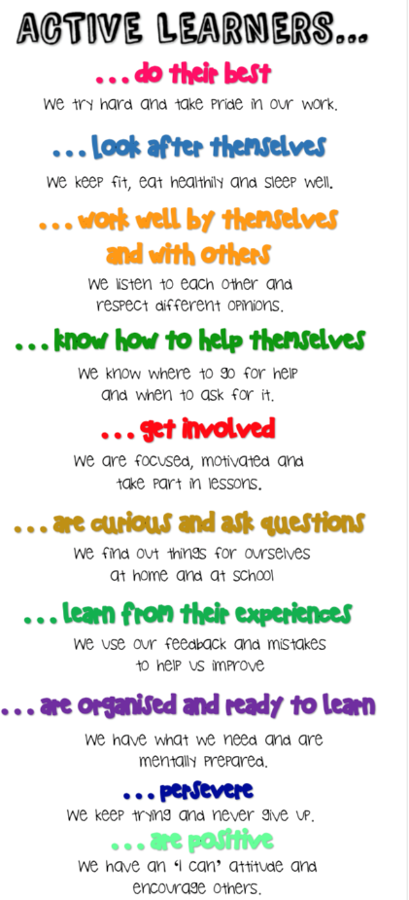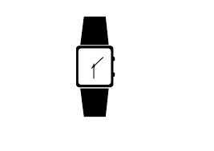

**SNACKS AND DRINKS**

A snack is provided every morning and it varies daily. If you wish to bring your own snack please make sure it is a healthy one, fruit is a great brain food! These should be kept in your book bag until break time. Please remember that we are a nut free school.

You will also need a named drinks bottle to keep in class, so you can stay hydrated through the day. Milk is also provided for children under the age of 5.

Active Learning is a big part of our learning here at Bledlow Ridge. Remember, getting involved, practising your skills and being curious is the best way to keep improving! These characteristics of Active Learning are behind everything we do in lessons. Which ones do you do really well? Which one do you need a bit more work on? When you come back in September we will be looking at each of these in more detail. Remember:

***Learning is not a spectator sport!***



We want you to have a great time at school, do as well as you can and leave your

new year group with some great memories. Your teachers will work hard to give you all the best opportunities, but you need to play your part! We expect that you will:

* do your best all the time
* show kindness and respect to all members of our school community
* be honest
* behave in a way that enables your best learning and doesn’t distract others.

**WHAT DO WE EXPECT FROM YOU?**

**ACTIVE LEARNING**

8:30am Playground gates open

8:40am Whistle blows

11:00 – 11:15am Break

12:30pm – 1:20pm Lunch

3:00pm School finishes

3:00 – 4:00pm After school clubs

**TIMES OF THE DAY**

All you need is a PE kit which needs to be named! All other equipment is provided. Children can have a small pocket toy but we hold no responsibility for it if its gets lost!

**Remember to make sure all your equipment (uniform and equipment) is named so we can return it to you if it gets lost!**

PE Wednesday and Friday

Books changed Tuesday and Friday

**IMPORTANT DAYS**

Mr Geraghty Class Teacher

Miss Hughes Teaching Assistant

Miss Dolan PPA Cover

**EQUIPMENT**

**STAFF**

Welcome to Reception!

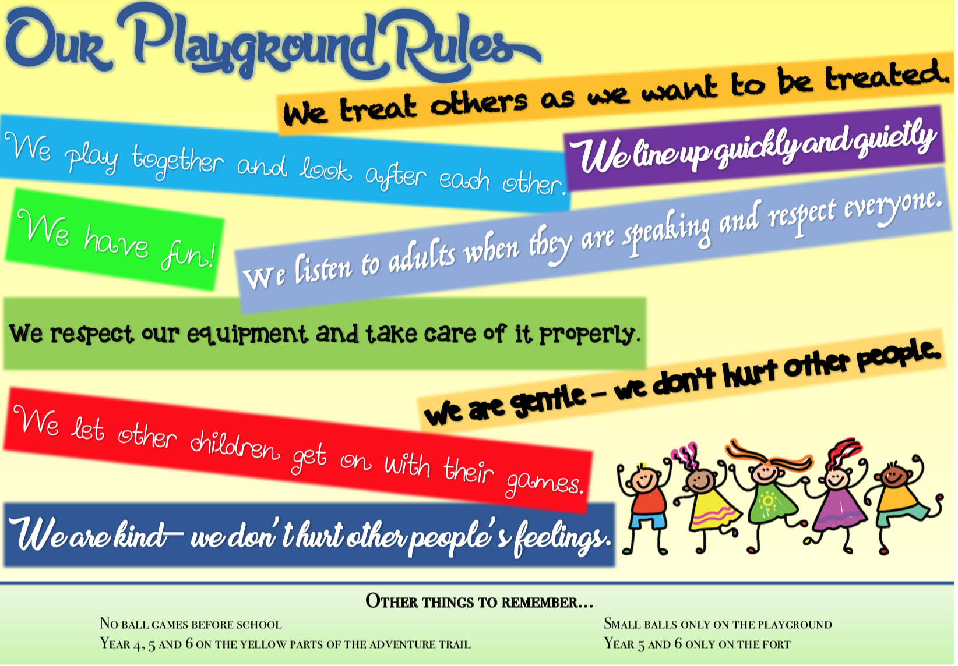



**Communication**

At Bledlow Ridge School we want a partnership between home and school, and an effective dialogue between both parties is the best way to facilitate this. If we have any concerns or worries about your child, we will contact you rather than waiting until parents’ evening or the annual report. Likewise, if you have anything you wish to raise with us, please feel free to do this at any time. The teachers are always on the playground after school, or if you wish you can make an appointment to meet at a mutually convenient time by emailing or ringing the school office. Before school, teachers are preparing for the day ahead so please do not try to speak with a teacher before school unless it can be avoided. There is always a member of staff at the main door in the morning who can pass messages or written notes on to the teachers.

**Support for Learning**

Homework will be given to the children each week and any support you can give with this will benefit your child. The spellings and Mathletics homework will reflect what your child has been doing in class so will be useful for consolidating their learning at home. If you would like any more information about what your child has been studying, feel free to talk to your child’s class teacher. We also run termly Parent Information Evenings on a range of topics linked to teaching and learning and how you can support your child. Ideas for topics of future evenings are always welcome!

**Volunteers**

We are always looking for willing helpers in class! Any time you can give is greatly appreciated and there are a range of roles available such as reading with children, supporting in class, supporting Art and DT projects and many more. If you would like to volunteer, please contact your child’s class teacher or the school office.

**Medical**

Any short-term medication (e.g. eye drops or antibiotics) your child needs must be taken to the school office at the start of the day where you will be asked to sign a form giving consent for us to administer the medication and stating the required dosage. If this form is not completed, we will not be able to administer the medication. If your child has a condition which requires medication to be in school permanently (e.g. inhalers or epi-pens) you will need to complete a healthcare plan for your child. The paperwork for this is available in the school office.

**FOR YOUR PARENTS…**