**Mathematics**

* addition and subtraction facts to 20
* doubling
* odd and even numbers
* counting in twos, fives and tens
* measuring length
* names and properties of 2D shapes

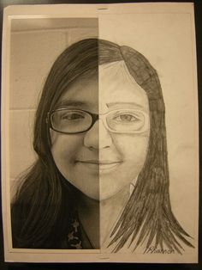

**Art and Design**

* portraits
* drawing a friend
* Picasso
* Andy Warhol
* Moving pictures

**Computing**

* Programmable toys and algorithms

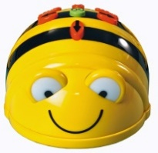

**Literacy**

* stories in familiar settings –

Rosie’s walk

* non-fiction writing – Labels and captions
* poetry – Bears by David Orme
* The Jolly Christmas Postman

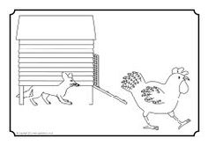

**P.E.**

* Dance – BBC Let’s move
* Games

**Music**

* Sounds Interesting

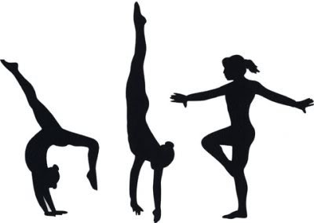

**PHSCE**

* New Beginnings

**Humanities**

* Around our school

**Science**

* Seasonal change –Summer into Autumn
* Animals including humans

**Year 1 Autumn Term**