Dear parents/carers,
We are very much looking forward to welcoming the children back on Monday 8th March. As always, safety is our first priority and having been through the renewed guidance to schools for opening I can now confirm the plans and procedures that will be in place to enable us to open as safely as possible.
Much of the guidance remains the same as before Christmas, with very few changes for primary schools, however, it is worth reiterating and refamiliarizing yourselves with the way the school will be operating. In particular there are changes to drop off and pick up times and procedures.

Attendance
This is once again mandatory unless your child has been advised to shield. If this is the case, or you have any other concerns about your child attending school, please contact the school office so we can discuss this further. It is important to note that your child should not attend school if:
- They are showing symptoms of Covid-19
- Anyone in the household is showing symptoms of Covid-19
- They, or anyone in the household, are awaiting results following a test for Covid-19
- They are required to quarantine following travel to another country
- They have been asked to self-isolate for any reason

Uniform and PE Kit
Children should attend school wearing uniform as normal. If the children have grown out of some items and you have not been able to get replacement ones then there can be some flexibility in the application of the uniform policy in the short term, until non-essential retail re-opens. However, please act within the spirit of the uniform policy wherever possible if needing to make changes (for example colours of replacement items).
As in the Autumn Term, children should come to school in their kit on the days they have PE.

Face Coverings
There is no requirement for children to wear face coverings in primary schools, however you can send one in with your chid if you wish. Please make sure they are able to put on and remove it themselves and have something to store it in.
Staff will be wearing face coverings in communal areas such as corridors.

Equipment
This will be provided as per the Autumn Term, so they are only required to bring a clear pencil case with them. They should also bring a water bottle, snack if in Key Stage 2 and a coat if required. If you wish, you can send in a spare change of clothes that will remain in school to be used in the event of children getting wet during PE and needing to change (although we will try to avoid this situation!)

Lunches
Following introducing hot lunches on a smaller scale during the recent partial school closures, we will be re-introducing hot lunches throughout the whole school. These will be eaten in classrooms (with the exception of Year R who will eat in the hall) to prevent mixing of bubbles and the children will be given fully recyclable containers and cutlery to use. Lunches should be ordered through the Innovate website as usual.

Drop Off and Pick Up
This is the area of most significant change. This has been done for two reasons: 1) to bring the hours in school for all children back to normal and 2) to avoid the bottle neck we were finding on the main path at the end of the day.
Drop off will now be between 8:30 and 8:45 for all pupils. Lessons will not start until 8:50 so please feel free to utilise the whole time period to ease traffic wherever possible. Children in Year R – 3 should make their way down the main path where they will be met by a member of staff to sanitise their hands. The children will enter the school site via the side gate to the playground and walk around the outside of the building to their classroom. Parents will leave the school site by walking in front of the hall and out via the delivery gates, keeping close to the fence when they exit the school site.
Year 4-6 will enter through the delivery gates keeping to the ‘tree’ side of the gates as they enter, then making their way around the outside of the building to their classroom. The diagram below shows this more clearly.
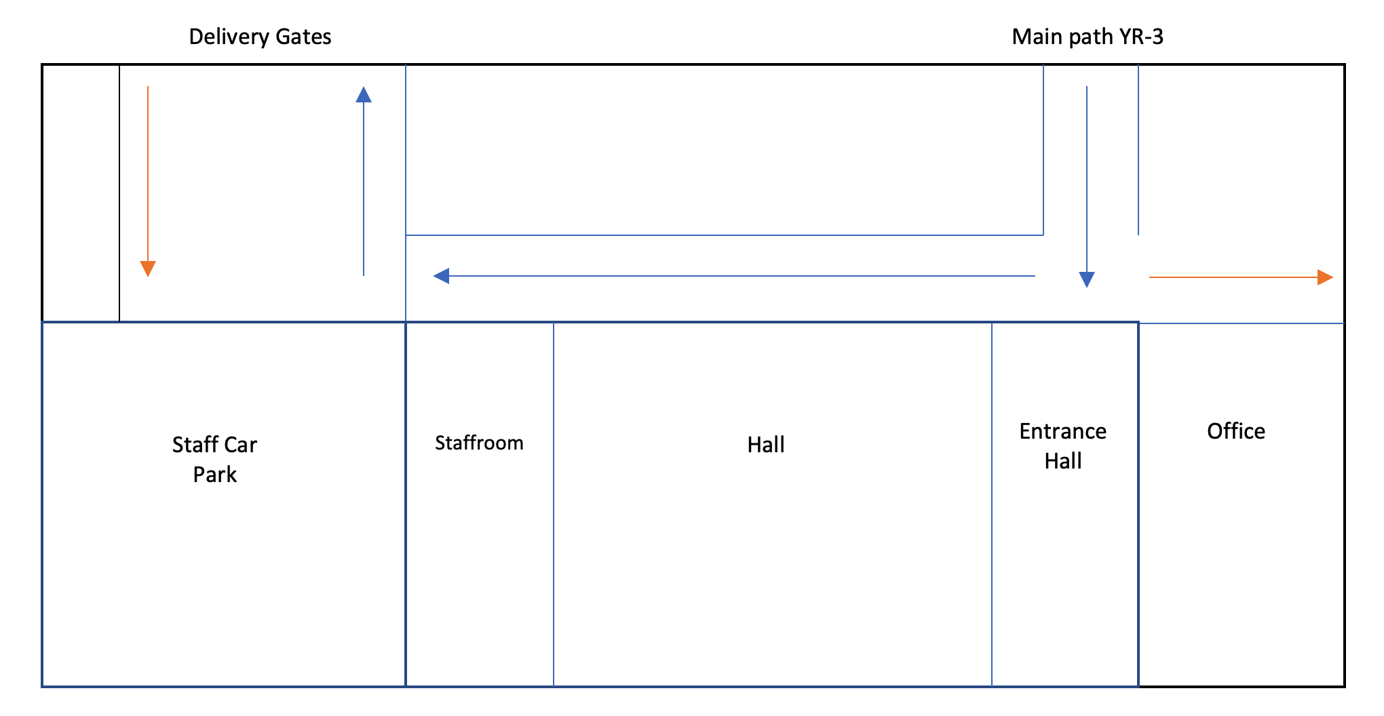
Front Garden
Year 4 - 6
The blues arrows indicate movement of parents and the orange lines movement of children.
Year R - 3
Parents in Year R – 3, do feel free to send them down the path unaccompanied if you wish to reduce the numbers on site.

Pick Up for Year R – 2 and all siblings will be at 2:55pm. The children will line up on the playground in their year groups. Parents will enter the school site via the main gate and make their way to the playground, collect their children and continue to walk around the building and exit the site via the delivery gates.
This process will be repeated for Year 3-6 at 3:10pm. If your child is in Key Stage 2 and you are happy for them to leave the school site unaccompanied and meet you outside the delivery gates, then please send an email to confirm this to office@bledlowridge.bucks.sch.uk
At both drop off and pick up it is vital everyone practices social distancing and leave the site and surrounding area swiftly to enable the least amount of mixing possible and a good flow of traffic.

Protective Measures
As before Christmas we will be continuing with all the measures put in place to minimise risk as far as possible. These include, but are not limited to:
- Hand washing
- Increased cleaning throughout the day
- Consistent bubbles of children and staff where possible
- Ventilation of spaces
- Social distancing where possible
- Arranging of the classroom and adaptation of spaces and activities
- Isolating classes where necessary after a confirmed case of Covid-19

Testing
Details of testing for households have been announced:
the government has confirmed twice-weekly testing using rapid lateral flow tests will be given for free to all families and households with primary, secondary school and college aged children and young people, including childcare and support bubbles, to help find more COVID-19 cases and break chains of transmission.
https://www.gov.uk/government/news/all-households-with-children-of-school-aged-to-get-rapid-covid-19-tests-per-person-per-week

This will not be mandatory but is being encouraged by government. Please read the linked guidance above carefully and decide if this is something you wish to take part in as a family. Testing kits can be ordered at the bottom of this page.
https://www.gov.uk/guidance/rapid-lateral-flow-testing-for-households-and-bubbles-of-school-pupils-and-staff

I will be writing to the children shortly to reassure them and welcome them back, but please do take the time to communicate the expectations and procedures for their return to school before 8 March.
We very much look forward to seeing you all then. As always, do not hesitate to ask any questions you may have.

Yours sincerely,

Alastair Haywood
Headteacher

