Headteacher’s Newsletter
September 2018

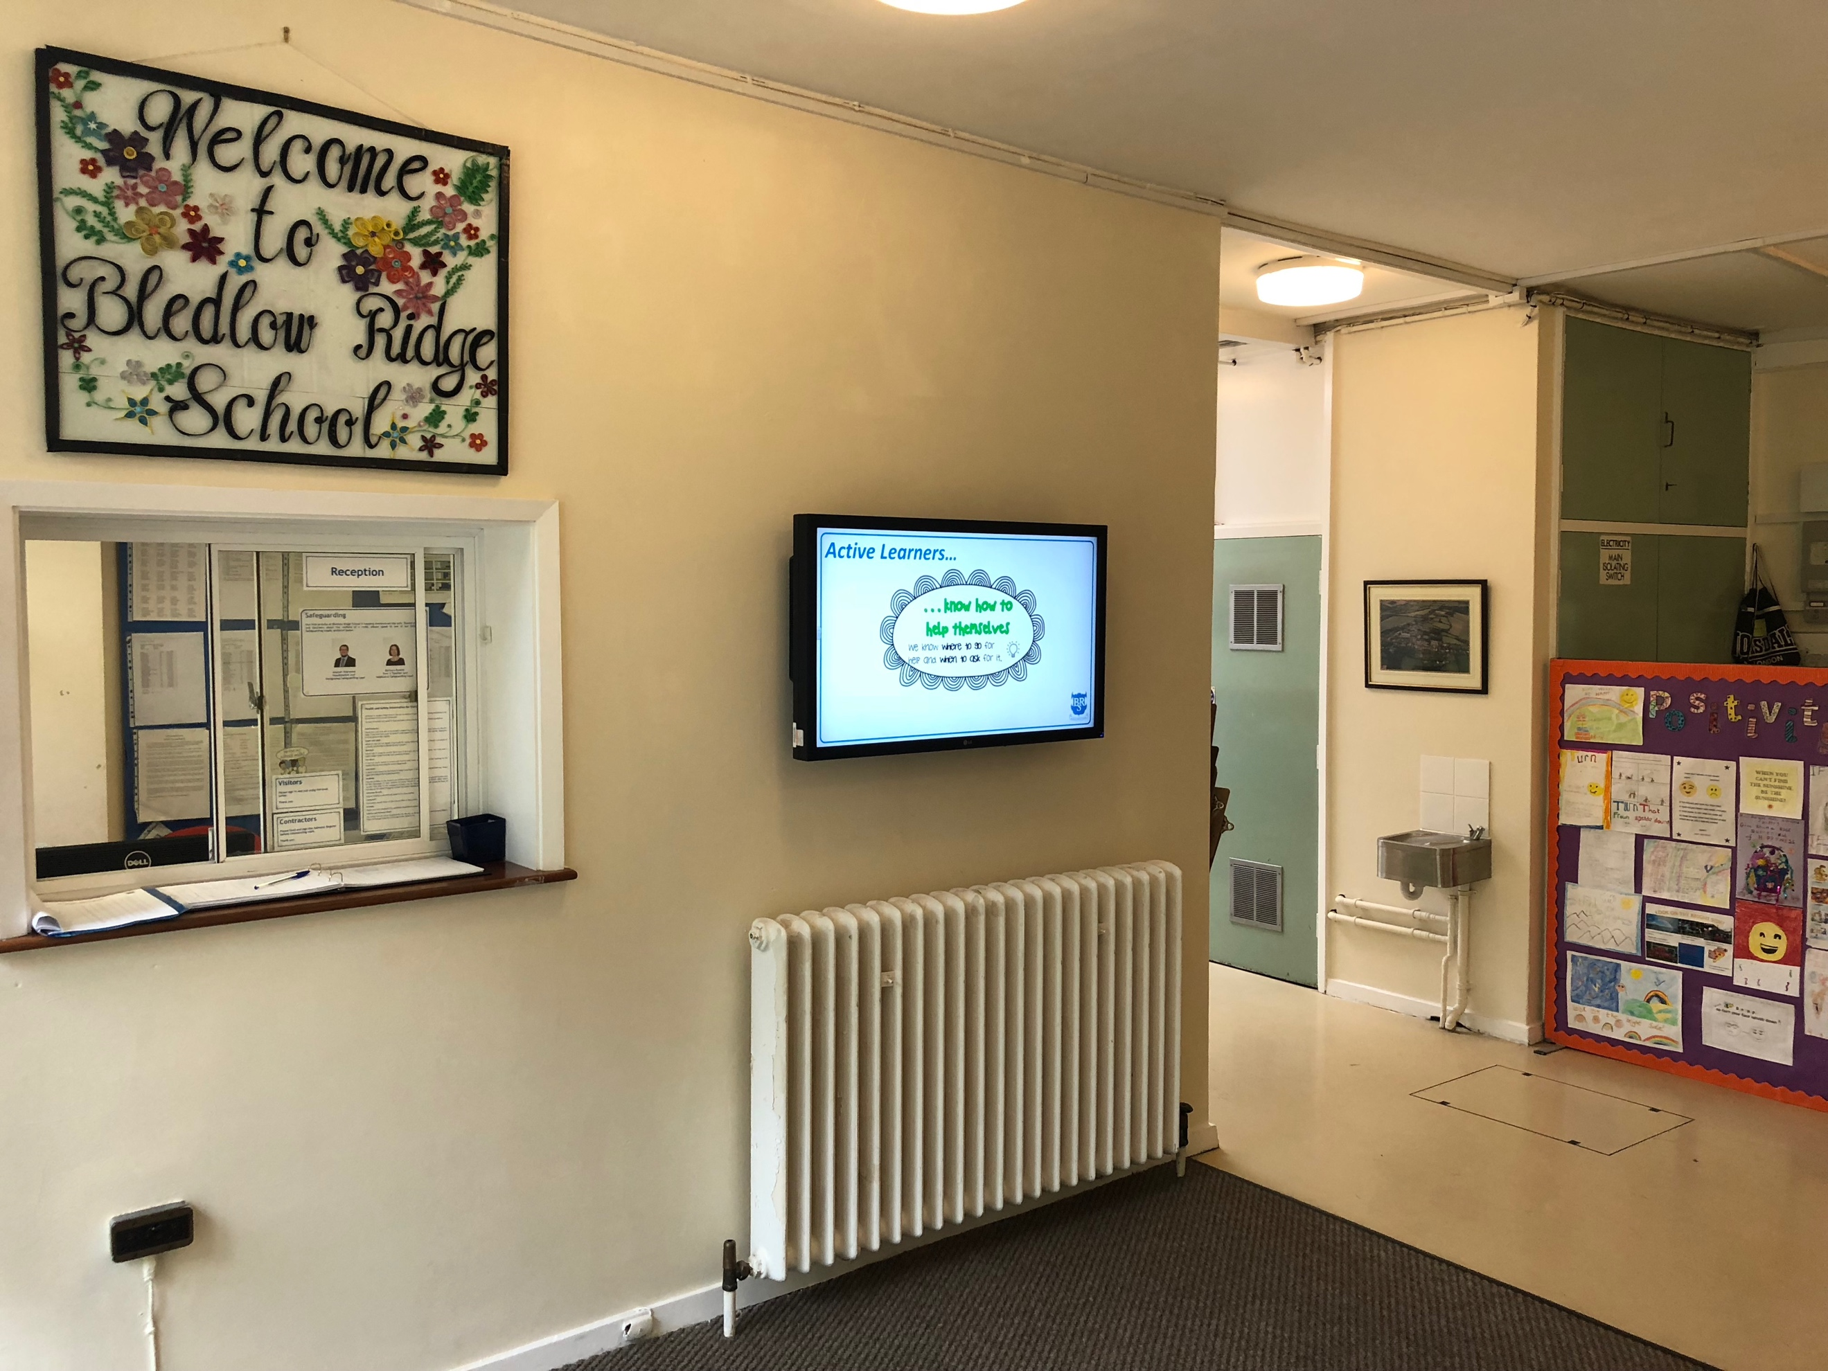
Dear Parents/Carers,

I am delighted to welcome you all to a new school year at Bledlow Ridge. I trust you have had a relaxing and restful break and made the most of the sunshine! A new year has brought a new décor to our entrance hall and Key Stage 1 corridor and I would like to express my huge gratitude to the parents (and children!) who gave up some of their holiday time to help with decorating the school. I hope you agree it looks much brighter and clearer now. Thank you also to Mrs. Lee who has created a wonderful welcome sign for our entrance hall.

I would also like to extend a warm welcome to all of our new Year R children and parents as they join our school community. I hope your time at Bledlow Ridge will be a very happy one. We are welcoming one new member of staff this term, Mrs. Gomes, who is joining us as a Teaching Assistant and will be working in Year 2.

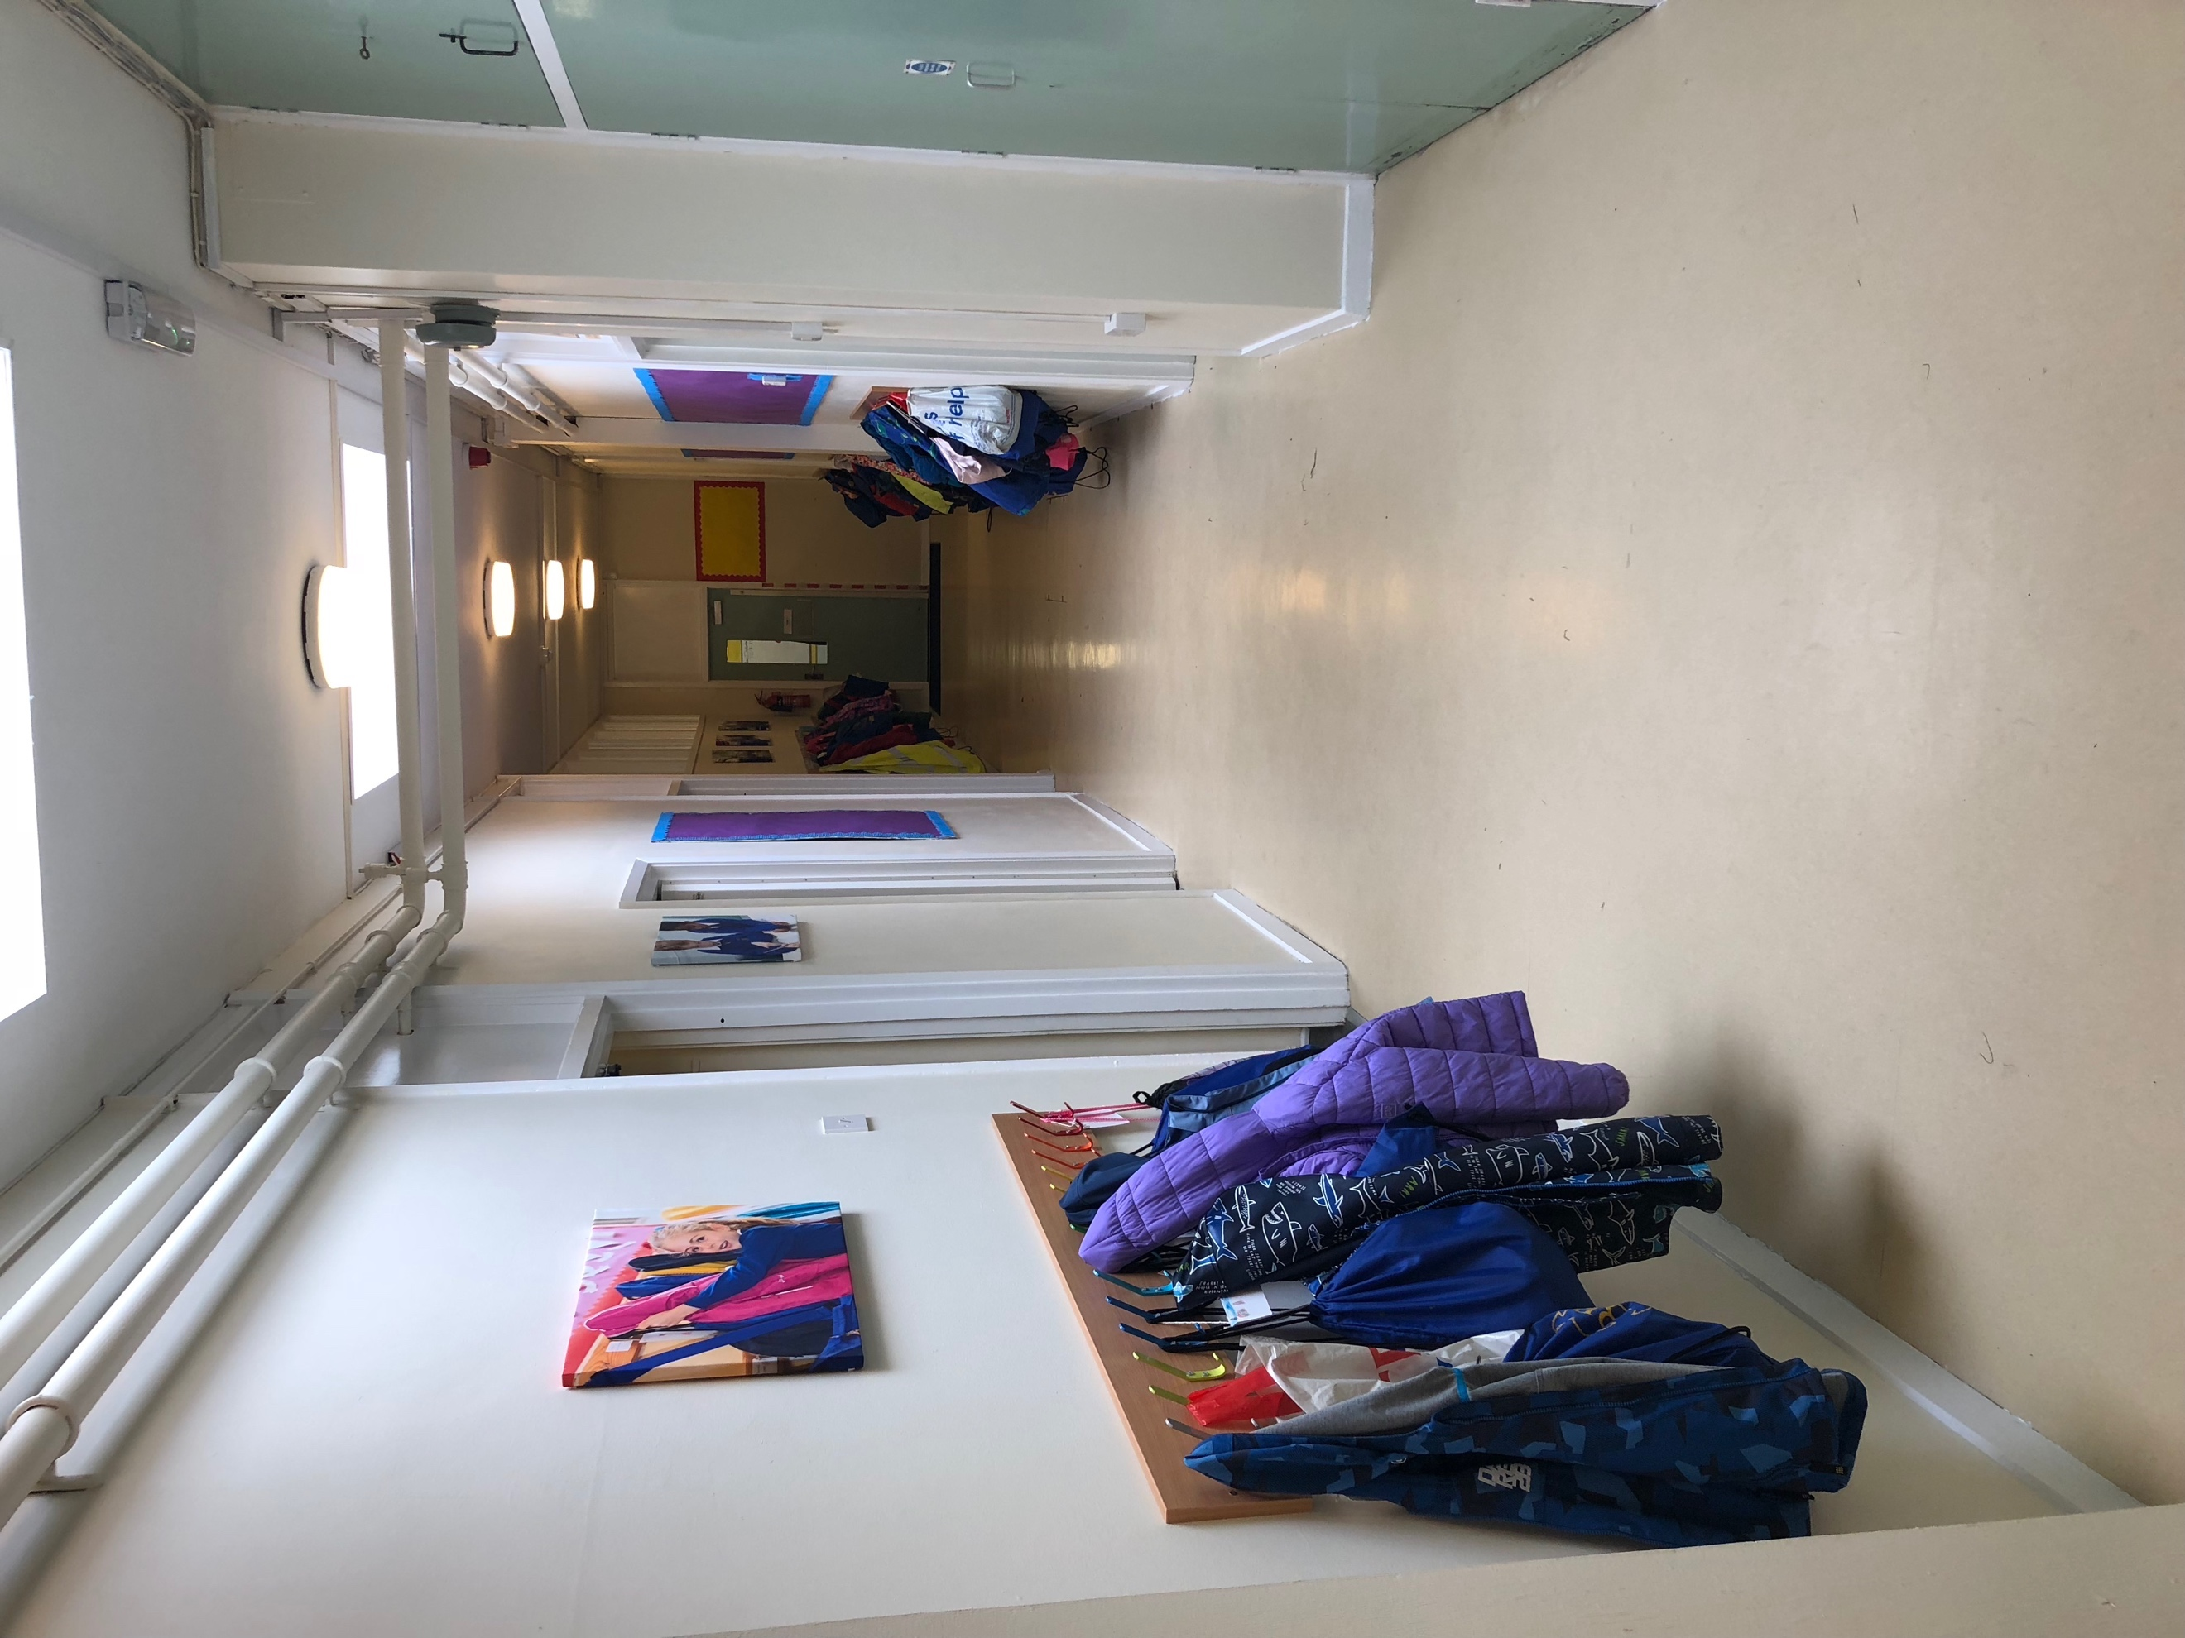
In our assemblies at the start of this term we reminded ourselves of Active Learning characteristics and also looked at how to approach new challenges. We looked at the mission of Felix Baumgartner and his parachute jump from space. During the assembly we discovered that he found new things scary and tricky but said the best way to overcome this was to jump out and have a go. We talked about how this is like our learning – sometimes it is scary and sometimes it is difficult, but we have to be willing to jump in and take a risk. Each time it doesn’t go as we were hoping we learn a little about how to do it better in the future.

This term we are starting our new Project Based Learning where the children will be working towards creating an ‘authentic outcome’ to showcase their learning. Over the course of this term we are fixing our learning around a whole range of projects including ‘Camelot’, ‘Arabian Nights’ and 'Food Glorious Food’. The children are working towards lots of exciting outcomes such as recipe books, news broadcasts and a living museum. We are very excited to see the end products!

Uniforms

The children are looking very smart in their uniforms, and in particular their shiny school shoes. Can I ask you to ensure you are sending your child to school wearing their uniform smartly? I have reattached the new uniform policy to this newsletter to remind you of the new expectations. In particular, can I remind you that ties are required for all pupils when they are wearing a shirt? As mentioned before the summer holiday there will be a transition period for the switch to jumpers or cardigans with logos.

Clubs

Clubs will be starting again from week beginning 17th September. The teachers have worked hard to produce a timetable of varied and exciting clubs and I am pleased to say we are able to offer many clubs over the course of this term. As before, sign up for clubs that are being run by the school will be through the Parents’ Evening section of Eschools. Each time slot is one space at the club, if you are able to sign up for a time slot your child’s place has been reserved. If there are no time slots for that particular club, then it is full.

These clubs will be supplemented by Premier Sports, Romar Sports, Smart Raspberry and Art Club. Information about this will be sent out by these providers. If you need a reminder of your Eschools password, then please contact the school office. We will advise you of the exact time that booking will open in a separate letter.

If your child is participating in a sporting club, please could they bring in their own kit from home (this does not have to be school PE kit)? This means their PE kit can remain in school for the duration of the half term, cutting down on children who do not have it for their PE lessons on the days following a club.

BRSA

The BRSA AGM will take place on Tuesday 25th September at 7pm. This is an opportunity for you to hear about all of the events that took place last year, what some of the funds have been spent on and to begin to plan for next year. As a member of the school community, you are all automatically members of the BRSA. I am aware that many of you give up your time to volunteer at a wide range of events and this is greatly appreciated. However, the planning and organising of these events invariably falls to the same small group of people. It would be excellent to see some new faces at committee meetings in order to share this load and even get some exciting new events on the calendar.

As mentioned previously, school finances are stretched both nationally and locally. The money from the BRSA is no longer spent on ‘luxuries’ but on essentials of school life in the most part. Your continued support and generosity are invaluable to enabling us to keep the school running with single age classes with a low pupil to teacher ratio.

Can you help?

As always, we welcome any help that you are able to offer on a voluntary basis in school. A sign-up sheet will be circulated next week so please do think about any time you may be able to offer. If you are able to offer a particular skill we would love to hear from you as well! If you are helping on a regular basis you will need to have a DBS check completed and undergo Child Protection training.

Parking

Please can I remind you to remain considerate in your parking at pick up and drop off times. The car park in Church Lane is always busy and it is not helpful for the traffic flow if cars park in unmarked spaces in order to drop children off. The safety of the children at this time is paramount and any cars that may be blocking children’s views or moving from an unexpected position may threaten this. With this in mind, please can I ask you not to park within 10 metres of the junction at the top of Church Lane as this impairs the view of children who are crossing the road in order to get to school? There have also been a few reported incidents of cars blocking the junction to Church Lane in order to make a drop off. This exacerbates the parking problem as cars are not able to enter or leave Church Lane to ensure a flow of traffic and local residents have also voiced their concerns about the safety of the children.

Daily Snacks

Children in Key Stage 1 are provided with a daily fruit snack. In Key Stage 2, children may bring a healthy snack (no crisps, biscuits or chocolate) to have at break time, and this should be brought in their bookbag (or rucksack for Years 5 and 6). Can I please remind that we are a nut free school, so snacks and packed lunches should not contain any nuts products?

Breakfast and After School Club

Breakfast and After School Clubs are up and running for this academic year. If you would like any more information please contact sarah@ridgekids.co.uk.

E-safety

Attached to this newsletter is the latest edition of the #DITTO e-safety magazine for your interest. We have also booked Alison Watts, part of the safeguarding team at BCC, to come and deliver an information evening for parents on the topic of Digital Wellbeing. This will be held on the evening of November 15th. More details to follow.

Thank you

As always, the work that we do in school would not be possible without the support from home. Parents remain a child’s first educator and by working together in partnership we have the best chance of ensuring that every child is able to reach their full potential during their time with us at Bledlow Ridge.

Mr. A. Haywood
Headteacher

Diary Dates

Monday 17th September After school clubs start
Monday 17th September Year 5 Meet the Teacher @ 2:30pm
Tuesday 18th September Year 6 Meet the Teacher @ 2:30pm
Tuesday 25th September BRSA AGM @ 7:00pm
Tuesday 2nd October Phonics for Reception @ 6:30pm
Tuesday 2nd October Key Stage 1 Progress In Phonics @ 7pm
Friday 5th October Harvest Festival @ 9:30am
Tuesday 9th October Parents’ Evening Years R 1, 2 and 3
Thursday 11th October Parents’ Evening Years 4, 5 and 6
Friday 12th October 11+ Results day
Tuesday 16th October Parents’ Evening Years 4, 5 and 6
Thursday 18th October Open Morning
Thursday 18th October Parents’ Evening Years R 1, 2 and 3
Friday 19th October Walkathon @ 1:30pm
Friday 19th October Break for half term @ 3pm
Monday 29th October INSET Day

