BLEDLOW RIDGE SCHOOL
PSHE HEALTH EDUCATION POLICY

Policy date: March 2021 Review Date: July 2022

School ethos

Our aims at Bledlow Ridge are threefold:
- To enable every child to reach his or her potential physically, emotionally, intellectually and socially;
- To ensure that each child feels included, valued and secure, and is able to recognise and appreciate his/her own worth and the worth of others;
- To encourage the children to become self-motivated and confident, and to acquire the skills and attitudes necessary for them to become independent, life-long learners.

With this in mind, our PSHE Policy has been written to reflect our aims throughout.

What is PSHE?

Personal, Social, Health and Economic Education is a distinct curriculum subject and has both statutory and non-statutory elements as defined by the DfE. High quality PSHE education supports pupils’ personal, social, health and economic development, helps to give them the knowledge, skills, strategies and attributes to make informed choices and decisions about the different opportunities and challenges life presents. Pupils will learn about relationships, health and wellbeing, keeping safe, managing their off and online lives, living in the wider world and financial education at an age appropriate level. Providing a high quality PSHE curriculum gives pupils opportunities to explore issues that are real and relevant to them in their daily lives in a safe and managed environment.

The aim of this policy is to:
- Provide information to staff, parents and carers, governors, pupils and other agencies regarding the organisation, content and approach to teaching PSHE Education
- Help parents and carers to understand PSHE Education and support them to work with their child to secure the very best outcomes for all pupils
- Demonstrate how the school meets legal requirements with regards to teaching Relationships Education, Sex Education and Health Education.
- To offer some experiences of careers education as part of our PSHE curriculum

The legal bit
At Bledlow Ridge school we teach the statutory parts of PSHE – Relationships education (please see our separate Relationships Education Policy) and Health Education through our PSHE curriculum. We also teach non-statutory Sex Education as part of PHSE provision (please see our Sex Education policy).
The Relationships Education, Relationships and Sex Education and Health Education (England) Regulations 2019, made under sections 34 and 35 of the Children and Social Work Act 2017, make Relationships Education compulsory for all pupils receiving primary education and Relationships and Sex Education (RSE) compulsory for all pupils receiving secondary education. They also make Health Education compulsory in all schools except independent schools.

We comply with the ‘Relationships Education, Relationships and Sex Education (RSE) and Health Education statutory guidance issued by the DfE
https://assets.publishing.service.gov.uk/government/uploads/system/uploads/attachment_data/file/805781/Relationships_Education__Relationships_and_Sex_Education__RSE__and_Health_Education.pdf
Whilst primary schools are not mandated to provide sex education, we offer this as part of our PSHE curriculum in addition to the statutory elements of sex education contained in the science curriculum. We are required to have regard to guidance issued by the secretary of state as outlined in section 403 of the Education Act 1996.

We follow the DfE guidance for teaching PSHE (updated June 2019)
https://www.gov.uk/government/publications/personal-social-health-and-economic-education-pshe/personal-social-health-and-economic-pshe-education
It is the statutory responsibility of the governing body to ensure the school has a compliant and up to date Relationships and Sex Education policy.

The curriculum

Intent - Why do we teach it?
We aim to provide high quality PSHE provision that will support pupils to develop life skills which will enable them to manage change, make healthy and safe choices, build character and be resilient, reflective and responsible members of society. Our PSHE provision has been designed to be age appropriate, whilst being sensitive to the needs of our whole school community to ensure PSHE provision gives our pupils an education which will support them both now and in the future. It is underpinned by the 2010 Equalities Act and provides an inclusive curriculum that promotes understanding and mutual respect for all. We reflect diversity within our curriculum to ensure that no pupil feels excluded and teach pupils to understand, respect and celebrate difference and challenge stigma. Our PSHE provision extends beyond the curriculum and includes themed days / weeks, assemblies and fully supports our school’s ethos and values. PSHE is part of our school’s broad and balanced curriculum supporting spiritual, moral cultural, social and cultural education, citizenship, equalities, and safeguarding. The personal, social, health and economic development of our pupils is a vital element of education and we aim to work collaboratively with parents/ carers to ensure our children are well informed and supported to make healthy, safe and positive choices in all aspects of their daily lives.

Implementation - What, where and when is PSHE taught
Our PSHE roadmap (Appendix 1) shows the current overview for our topics throughout the children’s education from Reception straight through to Year 6. A closer look at our PSHE Roadmap breakdown in the actual document (also viewable in Appendix 1) shows when each PSHE statement will be covered by each class. For further information about the relationships education and the sex education areas of study please see either the Relationship Education policy or the Sex Education policy.

What
At Bledlow Ridge school statutory Relationships Education and Health Education are taught as part of a structured spiral PSHE curriculum. We also teach Economic Education and relevant themes to support our pupils to manage their lives both now and in the future.
At Bledlow Ridge school we use the PSHE Association’s scheme of work for the overview, planning and delivery of PSHE. The programme of study is adapted to provide a relevant and age appropriate curriculum. We also use a mixture of Twinkl, SEAL and other online sources as part of our provision. We provide a spiral curriculum to ensure pupils are taught key aspects of PHSE at a relevant and age appropriate level and in line with their continuing personal, social and emotional development.

Relationships Education
Our PSHE curriculum covers statutory Relationships education (please see Relationships policy for further details). Relationships Education in primary schools focuses on teaching the fundamental building blocks and characteristics of positive relationships, with particular reference to friendships, family relationships, and relationships with other children and adults. By the end of primary school pupils will have been taught content on:
- Families and people who care for us
- Caring friendships
- Respectful relationships
- Online relationships
- Being safe
Pupils will be taught Relationships Education from Reception at an age appropriate level. Further details on what we are required to teach can be found in appendix 2 (DfE Relationships outcomes)

Sex Education
As part of our PSHE provision we teach sex education. This is an important and recommended aspect of the curriculum. As a non-statutory element of PSHE parents / carers have the right to withdraw their child from designated sex education lessons. We encourage parents and carers to talk through any concerns they may have and make an informed choice about whether to exercise the right to withdraw their child. Please see our sex education policy for further details.

Health Education
We deliver statutory Health education through our PSHE curriculum and ‘Time To Talk’ days. Health Education aims to teach pupils about physical and mental wellbeing and give pupils the information that they need to make good decisions about their own health and wellbeing. It should enable them to recognise what is normal and what is an issue with regards to themselves and others; pupils will be taught how to seek support as early as possible and from a safe and trusted source. By the end of primary school, pupils will have been taught content on:
- Mental wellbeing
- Internet safety and harms
- Physical health and fitness
- Healthy eating
- Facts and risks associated with drugs, alcohol and tobacco
- Health prevention
- Basic first aid
- Changing adolescent body*
*The changing adolescent body and puberty education is part of the statutory Health Education curriculum and is mandatory for all pupils. We teach the correct scientific names of all body parts from Reception to Year 6. A list of key vocabulary can be found in appendix 3. Introducing the scientific names of genitalia is recommended by the NSPCC, the PSHE Association and is recognised good practice, supporting the safeguarding of pupils. DfE outcomes for Health Education can be found in appendix 2.

Living in the wider world/Economic Education
Our PSHE curriculum covers Economic Education and Living in the Wider World. Pupils will learn about areas such as manging money, saving and enterprise skills, careers education, climate change, personal safety both online and off.

When / How
At Bledlow Ridge school PSHE is a taught subject. PSHE is timetabled once a week and delivered by class teachers. The PSHE curriculum has been designed to help pupils develop their knowledge and skills over time, embedding learning to ensure pupils receive a relevant and age appropriate education to support them in their lives now and in the future. PSHE is taught in units and the themes are available to view through the Curriculum Term Overview given out every term.

Managing difficult questions and confidentiality
In PSHE pupils learn about personal safety and the law. Should a pupil make a disclosure to a member of staff this will be reported to a designated safeguarding lead and followed up in accordance with our disclosure procedures. Please see our safeguarding policy on the school website for further information.
All aspects of PSHE are underpinned by shared and understood ground rules (these can be viewed in appendix 2) with lessons being delivered in a safe and well managed environment. To ensure the content and delivery of PSHE education is appropriate and relevant to our pupils we use simple baselines to ascertain what pupils already know, and what they would like to learn. Distancing techniques are used in PSHE education, which provide depersonalised examples which support children to explore what is being taught without sharing their own personal experiences in the lesson. Pupils are encouraged to ask questions and raise issues in a respectful and appropriate manner. Some questions or issues raised may not be appropriately answered in whole class lessons and these will be followed up separately on an individual or group basis. A worry or question box is available for pupils who do not feel confident to ask questions or wish to have a separate conversation with a member of staff. Given ease of access to the internet, children whose questions go unanswered may turn to inappropriate sources of information instead. We also respect that some questions are better addressed at home with parents/ carers and the school will share information with parents/carers on an individual basis should the need arise. Whilst it is vital to have trust and openness we cannot offer total confidentially to pupils. Any disclosures or areas of concern will be followed up in accordance with our safeguarding procedures.

How delivery and content will be made accessible to all pupils including SEND
This will be differentiated on a case by case teacher led decision, depending upon the specific needs of the child in question. These lessons may be but not exclusively be either 1-1 lessons incorporated into games or stories in order to make them accessible to the child. The child may be in the class with the other students or out of class on a 1-1 basis.

Impact
PSHE provision provides pupils with well-chosen opportunities and contexts to explore and embed new knowledge that can be used confidently in real life situations
- Pupils are able to form healthy, happy relationships with other children and adults and recognise the features of unhealthy relationships and have strategies to challenge negative behaviour of others and seek help when needed
- Pupils know how and when to ask for ask for help and where to access support
- Pupils are well informed and recognise the risks they may encounter both on and off line and are able to make safe choices
- Pupils are enabled to take responsibility for their actions and understand the implications and consequences of their own decisions
- Pupils are well prepared for the next steps of their lives
- Pupils have the knowledge, skills and attributes to live healthy, happy lives
- Pupils understand and respect differences between themselves and others

Roles and Responsibilities
The Governing Body will approve the policy and hold the Headteacher to account for its implementation.
The Headteacher is responsible for ensuring PSHE is taught consistently across the school and for managing requests with regards to the parental right to withdraw from non-statutory Sex Education.
The PSHE lead is responsible for leading and managing the subject. Teachers are responsible for delivering PSHE. Pupils are expected to fully engage with PSHE provision and treat other with respect.

Working with outside agencies and visiting speakers
Any agencies or visiting speakers will be given and asked to sign the school safeguarding documentation in order to attend a session. They will also have their identification check by a member of staff unless know to staff already.

Monitoring, evaluation and training
- PSHE provision will be monitored and evaluated by the PSHE lead, SLT and Governors in line with the monitoring cycle agreed by the school. The PSHE policy will be reviewed annually.
- To ensure staff are confident to deliver all aspects of the PSHE curriculum, access to online, in school, local and national training will be made available and in accordance with the school’s CPD programme for staff development.
- Students are given opportunities to provide reflections of our PSHE curriculum throughout the year in all year groups.
Working with parents
It is vital that parents and carers know what is being taught and how to support their child/children. The PSHE curriculum overview is published on the school website along with the PSHE policy, Relationships policy and Sex education policy. Appendix 1 shows what is being taught by year group.
We have an open-door policy for any parents/ carers who wish to find out more about our PSHE provision. We understand that parents and carers may wish to approach the school to access help with concerns they may have about their child and where they can go to obtain further support.
Our PSHE policy and PSHE curriculum overview can be found on the school website. We welcome and encourage parents and carers to make an appointment with the class teacher or the headteacher to discuss any aspect of the PSHE curriculum or to raise any concerns they may have regarding this vital area of education. This should always be raised through the school office so that an appropriate meeting time can be arranged.
Parents and carers are only entitled to withdraw their child from designated Sex education lessons (please see the Sex education policy for further details) and there is no right to withdraw from PSHE which includes statutory Relationships Education and Health Education. The science curriculum also includes content on human development, including reproduction, for which there is no right to withdraw from. We highly recommend all students receive the full PSHE curriculum.

Useful information for parents
A designated area of the School website signposts parents to trusted external websites such as ParentZone, NSPCC, ThinkUKnow and the DfE guide for parents.

9.Linked policies
Safeguarding
Anti - Bullying Policy
Relationships Education Policy
Sex Education Policy
Food Policy

10. Policy development
This policy was developed by the PSHE lead in consultation with school governors, a readability focus group of parents and pupils (this has been outlined at the end of this document after the Appendixes).

Appendix 1
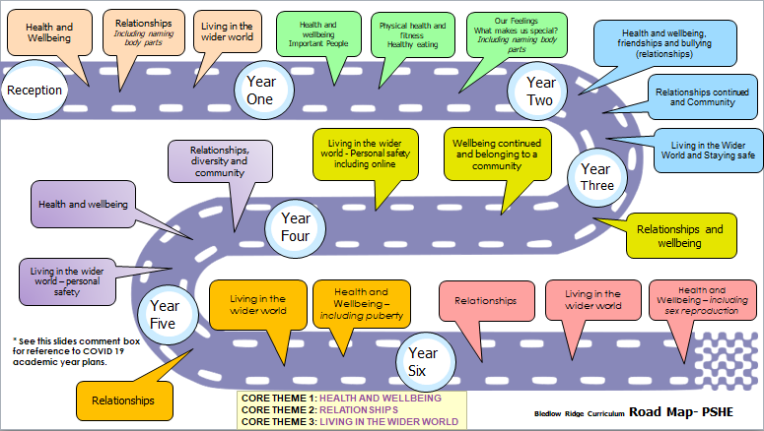
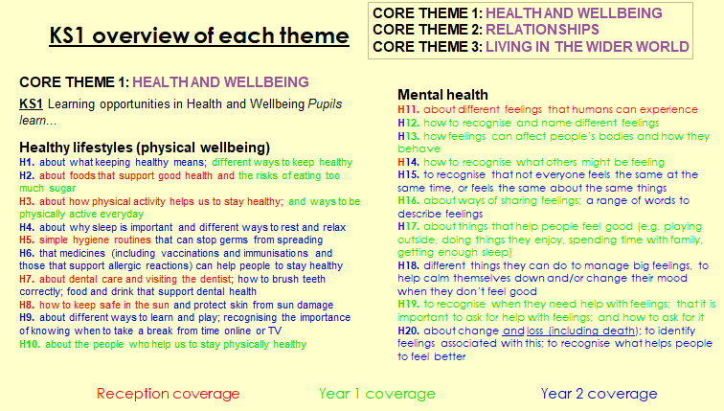

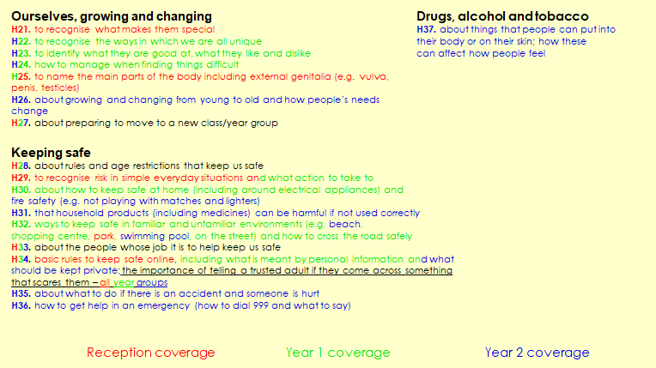

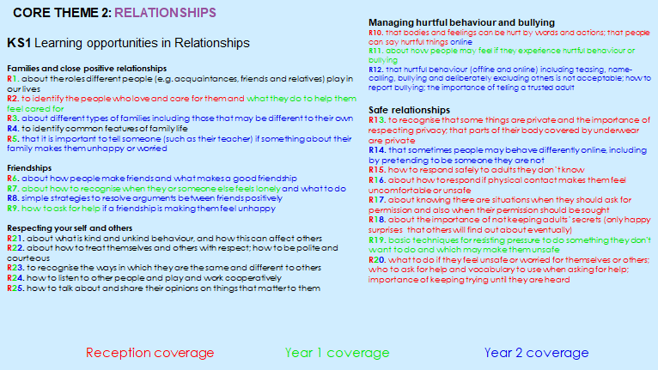
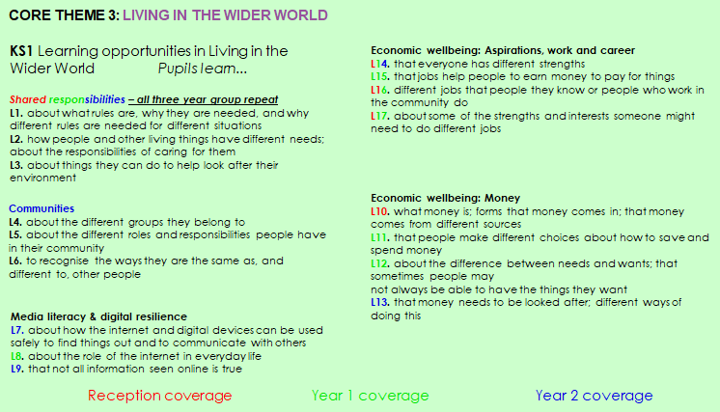

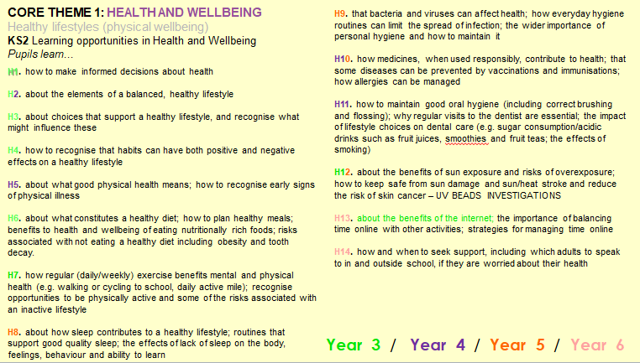
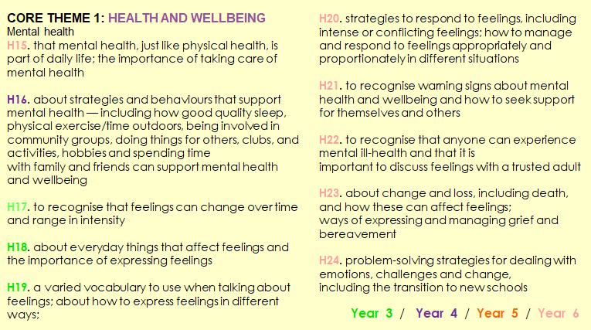

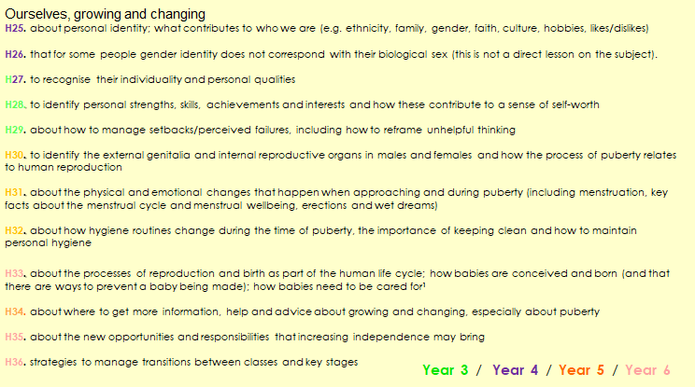
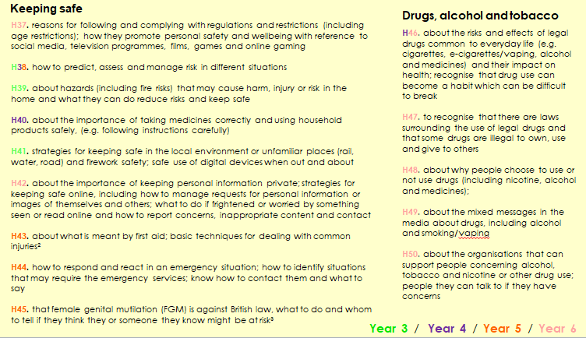

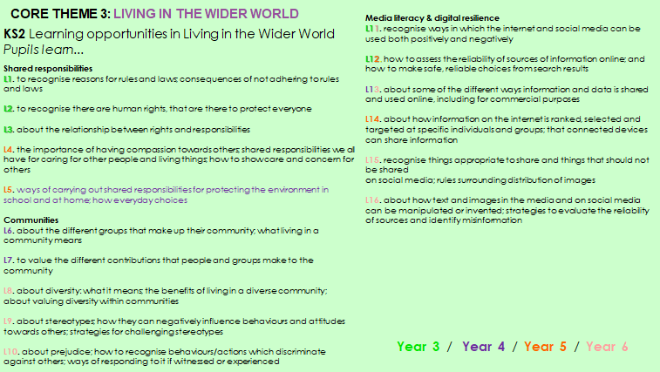

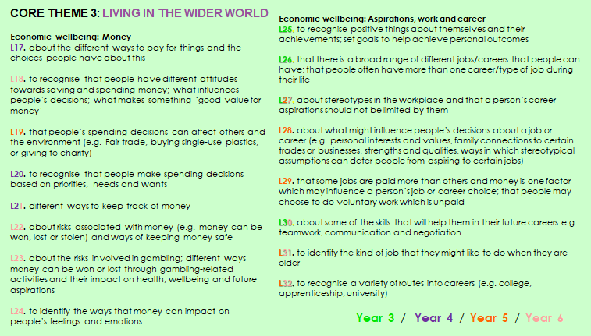

Appendix 2
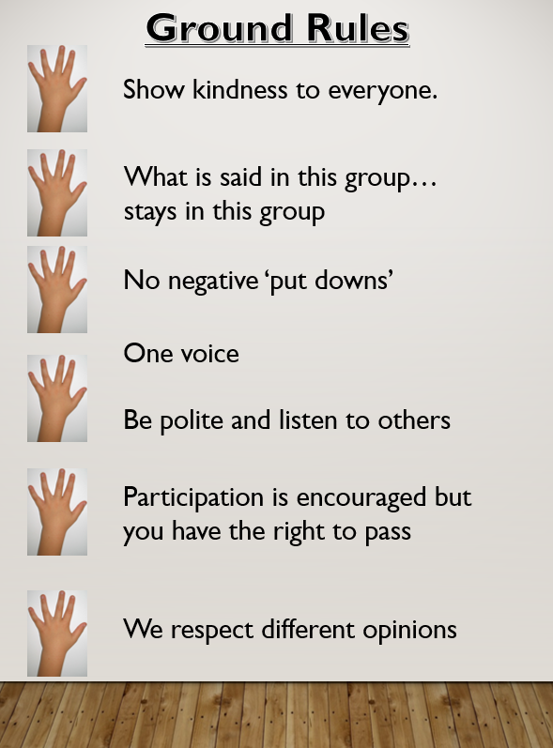

Appendix 3
DEF information from statutory guidance
Relationships – primary
https://www.gov.uk/government/publications/relationships-education-relationships-and-sex-education-rse-and-health-education/relationships-education-primary
Health education (the DfE has not separated this into Primary and Secondary)
https://www.gov.uk/government/publications/relationships-education-relationships-and-sex-education-rse-and-health-education/physical-health-and-mental-wellbeing-primary-and-secondary
DfE Guide for parents
https://assets.publishing.service.gov.uk/government/uploads/system/uploads/attachment_data/file/812593/RSE_primary_schools_guide_for_parents.pdf
Please note these are available other languages (Urdu, Somali , Arabic).

Suggestions for policy development
- More information was asked to be added in regards to physical health and well-being in relation to eating habits and relationships with food. This section was adapted in our food policy to cover how children do not always choose their food or control their portion sizes. Both children and parents will be made aware of the correct portion sizes and given some suggested sugar swap options to help them make informed choices in their diets.
- Anxieties over food was also brought up and can be addressed or resolved early on by ensuring that discussion are made over how food importantly provides us with the necessary energy needed for daily life. Body image is also an area that can be discussed sensitively through-out both Key stages as and when appropriate to do so.

Miss Claire West – PSHE lead with staff or working group pulled together all relevant information including relevant national and local guidance / guidance from Public Health PSHE lead.

Staff consultation – all school staff were given the opportunity to look at the policy and make recommendations.

Parent/stakeholder consultation – parents and any interested parties were invited to read thorough the final drafted version of the policy and feedback on any questions or queries that they had. The school has an open door policy that allows parents the opportunity to ask questions about our policies at any point in during the school year. Suggestions for the policies were created after feedback from the readability focus group comments and queries.

Pupil consultation – Miss West (PSHE lead) or Mr. Gage (PSHE governor) have and will continue to seek consultations when appropriate, regarding PSHE lessons and questions raised to shape further lessons. This has been and may in future be achieved through a small focus group who can then give their consent to review or answer a questionnaire in class. In addition to these meetings, throughout the year, teachers will also be completing a reflective assessment of each terms targets and provide children with the opportunity to review each topic unit once completed.

Ratification – this policy was shared and ratified with governors.

This policy was created with the support of Carol Stottor (PSHE Lead for Public Health BCC).

