BLEDLOW RIDGE SCHOOL
SEX EDUCATION POLICY

Policy date: March 2021 Review Date: July 2022

School ethos

Our aims at Bledlow Ridge School are threefold:
- To enable every child to reach his or her potential physically, emotionally, intellectually and socially;
- To ensure that each child feels included, valued and secure, and is able to recognise and appreciate his/her own worth and the worth of others;
- To encourage the children to become self-motivated and confident, and to acquire the skills and attitudes necessary for them to become independent, life-long learners.

With this in mind, our Sex Education Policy has been written to reflect our aims throughout.

At Bledlow Ridge Primary school we are committed to providing a safe place to learn about staying safe, saying no and speaking up when children are concerned or uncomfortable.

Aims of the Sex Education policy
All state funded primary schools are required to teach Relationships Education and to have a Relationships Education policy by September 2020 (see our Relationship Policy for further information).

The aim of this policy is to
- Provide information to staff, parents and carers, governors, pupils and other agencies regarding the organisation, content and approach to teaching Sex Education
- Help parents and carers to understand Sex Education and support them to work with their child to secure the very best outcomes for all pupils
- Demonstrate how the school meets legal requirements with regards to teaching Sex Education
Legal Requirements
To comply with The Relationships Education, Relationships and Sex Education and Health Education (England) Regulations 2019, made under sections 34 and 35 of the Children and Social Work Act 2017, make Relationships Education compulsory for all pupils receiving primary education. They also make Health Education compulsory in all schools except independent schools.

To comply with the Relationships Education, Relationships and Sex Education (RSE) and Health Education statutory guidance from the DfE (June 2019)

To comply with the requirements to have an up to date Relationships policy developed in consultation with pupils, parents and carers (Education Act 1996) and in line with the DfE statutory guidance on Relationships Education, RSE and Health Education( June 2019)

To have due regard to the Equality Act (2010) which requires schools to prevent discrimination, advance equality of opportunity and foster good relation between different groups. The protected characteristics that apply to school age children are disability, race, religion or belief, sex, sexual orientation, gender reassignment, pregnancy and maternity.

To fulfil statutory safeguarding duties and ensure any safeguarding issues arising from Sex Education lessons are identified and followed in accordance with the school safeguarding policy

At Bledlow Ridge Primary school we teach puberty and human reproduction in Year 6 as part of both our Science and our Relationships and PSHE curriculums. As Sex Education is not statutory at primary we wish to state the right of parents and carers to withdraw their child from designated Sex Education lessons. However, if the lesson is a science based lesson then parents do not have a right to withdraw. The DfE have stated that ‘pupils should know how to report concerns or abuse, and have the vocabulary and confidence needed to do so’ - Being Safe.

In Ks1, we don’t teach sex education in PSHE, however we will cover ‘Being Safe’, an aspect of the statutory Relationships Education curriculum which includes learning related to privacy and safeguarding. It is recommended children are taught the correct names of all body parts. A full list of words and when they are taught can be found in Appendix 5 (an attached document labelled Joint briefing on Human Developments and Reproduction in Primary Schools).

Development of the policy
This policy was developed by the PSHE lead in consultation with school governors, a focus group of parents and pupils (this has been outlined at the end of this document after the Appendixes).

This policy links to the PSHE policy, Sex Education Policy, Child Protection Policy, Anti-Bullying Policy, Equalities policy and the School Behaviour policy.

Definition of Sex Education
Sex Education links in closely with Relationship Education taught at Bledlow Ridge Primary school through the PSHE curriculum and teaches pupils what they needs to know by the end of year 6 as defined by the DfE guidance (See Appendix 1). Sex Education gives pupils the information they need to help them understand the correct terminology for body parts, how to say no, what is appropriate and inappropriate touch, understand the reproductive system, identify potential dangers and how to report any worries or concern or abuse and where to access help when needed.

The Curriculum
Intent - Why teach Sex Education?
High quality Sex Education will support pupils to:
- Understand the correct terms for body parts which is particularly important when if a child makes a disclosure
- Strategies to manage the changes during various stages of puberty
- Show respect for others and recognise diversity within relationships, treating each other with kindness, consideration and understanding
- Understand the how and who to report concerns to
- Understand the importance of recognising and establishing their own personal boundaries and privacy
- Understand and respect differences and combat all forms of bullying and discrimination
- Recognise unhealthy relationships, inappropriate behaviour and bullying and to report concerns or abuse and are taught the appropriate vocabulary to do so (including signposting to trusted online support services such as Childline)
- Ask a trusted adult rather than go on line with regards to any concerns about sexual issues and avoid viewing any inappropriate material or entering into social media conversations that can could cause them harm
- Recognise intimate physical relationships are for adults

Implementation
Sex Education is delivered through the PSHE and Relationships curriculum. These aspects of the Sex Education as defined by the DfE will be taught at an age appropriate level. Further details can be found in Appendix 4 showing our School Road Map of the Curriculum Aims.

To ensure the content and delivery of sex education is appropriate and relevant to our pupils we use simple baselines to ascertain what pupils already know, and find out what they would like to learn. Distancing techniques are used to teach sex education, which provides depersonalised examples which support children to explore what, is being taught without sharing their own personal experiences in the lesson. We provide a safe space for children to talk in but encourage children to ask questions through an anonymous question box which may then be answered or may be passed onto a parent or carer depending to the nature of the questions asked by the individual and who is best to provide the answers. We provide an inclusive curriculum that promotes understanding and mutual respect for all. We reflect diversity within our curriculum to ensure that no pupil feels excluded and teach pupils to respect difference, promote equality and challenge stigma.

Outcomes for Relationships Education are defined by the DfE and cover:

- Respecting yourself and others
- Media literacy & digital resilience
- Being safe*
- Ourselves, growing and changing
- Keeping safe**
- Safe relationships

*We teach the scientific names of body parts (head, neck, arms, elbows, legs, knees, face, ears, eyes, hair, mouth, teeth, penis, testicles, vulva in Reception and Year 1)
** We teach about age restrictions and how FGM is illegal in the UK in Year 6.

Sex Education is taught as part of the PSHE curriculum in the context of Relationships Education but is not a mandated requirement.

What we use – High quality assured resources provided from the PSHE Association programme of study, Twinkl, SEAL and other trusted online teaching providers.

Who – Sex education starts by learning scientifically correct body parts in Reception and Year 1. They also learn that our private parts our private to us. It is therefore taught by teachers in Reception, Year 1, Year 5 and 6; where they then learn about puberty and human reproduction.

When – PSHE lessons are timetabled for at least 30 - 50 minutes per week, but can also be covered with-in additional lessons in various topics and during Time To Talk Days.

How delivery and content will be made accessible to all pupils including SEND – This will be differentiated on a case by case teacher led decision, depending upon the specific needs of the child in question. These lessons may be but not exclusively be either 1-1 lessons incorporated into games or stories in order to make them accessible to the child. The child may be in the class with the other students or out of class on a 1-1 basis.

Where you can view curriculum information – please see Appendix 4 (year by year overview of the PSHE provision and where we cover Relationships Education – plus a vocabulary lists in Appendix 5)
Managing Difficult Questions – All aspects of PSHE are underpinned by shared and understood ground rules (these have been created and reviewed by the children, staff and governors - attached as Appendix 3) with lessons being delivered in a safe and well managed environment. Pupils are encouraged to ask questions and raise issues in a respectful and appropriate manner. Some questions or issues raised may not be appropriately answered in whole class lessons and these will be followed up separately on an individual or group basis. A question box or worry monster is available for pupils who do not feel confident to ask questions or wish to have a separate conversation with a member of staff. Given ease of access to the internet, children whose questions go unanswered may turn to inappropriate sources of information.
Whilst it is vital to have trust and openness we cannot offer total confidentially to pupils. Any disclosures or areas of concern will be followed up in accordance with our safeguarding procedures. We also respect that some questions are better addressed at home with parents/ carers and the school will share information with parents/carers on an individual basis should the need arise.

Impact
High quality Sex Education will enable our pupils to:
- Enjoy healthy and positive relationships with others
- Understand how their behaviour affects others and visa versa
- Make positive choices about how they cultivate and nurture friendships and relationships
- Be aware of and respect different types of relationships in accordance with the Equalities Act
- Recognise unhealthy relationships and have strategies to challenge negative behaviours
- Know what to do if there are problems within relationships both on and off line, how to keep safe and where to go to seek help
- To know when it is appropriate to use scientific words
- To be able to report their concerns using scientific names to remove any ambiguity over a reported situation. This removes the use of ‘pet names’ or terms only referred to by family members that to an outsider would be misunderstood and therefore the gravity of the situation would either not come across in the report or be overly cautious.

Confidentiality and safeguarding
Any personal disclosures made by pupils will be followed up in accordance with the school’s child protection policy. Teachers will report any safeguarding concerns to the DLS and share concerns with parents/carers according to the school’s safeguarding procedures.

Roles and Responsibilities
Although Sex Education is not statutory in Primary schools, it is still the responsibility of the governing body to ensure the school has a compliant and up to date Sex Education policy if being taught at the school. The Governing Body are required to approve the policy and hold the Headteacher to account for its implementation.
The Headteacher is responsible for ensuring PSHE is taught consistently across the school and for managing requests with regards to the parental right to withdraw from non-statutory Sex Education.
The PSHE lead is responsible for leading and managing PSHE which includes statutory Relationships Education. Teachers are responsible for delivering PSHE. Specific teachers in school have been trained in delivering the reproductive elements of the SEX education. Pupils are expected to fully engage with all scientific based lessons, provision given and treat other with respect.

Working with outside agencies and visiting speakers
We currently do not work with any outside agencies or visiting speakers for any aspect of our Sex Education curriculum content.

Monitoring, evaluation and training
PSHE provision will be monitored and evaluated by the PSHE lead, SLT and Governors in line with the monitoring cycle agreed by the school. The PSHE policy will be reviewed annually to make sure that it is complying with the latest Sex Educational advice being provided by the DfE.

To ensure that the designated staff members teaching the sex education elements are confident to deliver all aspects of the Sex Education curriculum, access to online, in school, local and national training will be made available and in accordance with the school’s CPD programme for staff development.

Working with parents and carers (consulting, informing and supporting)
An initial consultation with the governors took place in November 2020. In addition to this meeting, a focus group consultation was set up to review and proof read our PSHE Policies (PSHE, Relationship and Sex Education Policies) and school roadmap in order to consult, inform and receive feedback upon them. A selection of parents were able to have time to look through the polices as part of a small group readability task with members of the Governing body in attendance. Further web page links to the polices were also added to our school website to allow all parents to see and review the policy (see Policy development which is located after the Appendixes).
Parents and cares are only entitled to withdraw their child form designated sex education lessons. Parents and carers do not have the right to withdraw their child from PSHE which includes statutory Relationships Education and Health Education (including the changing adolescent body/puberty). The science curriculum also includes content on human development, including reproduction, which there is no right to withdraw from. We highly recommend all students receive the full PSHE curriculum. See Appendix 2 for guidance to parents from the DfE on your rights to be excused from Sex Education (commonly referred to as the right to withdraw).

Appendixes

Appendix 1 DfE descriptors
https://www.gov.uk/government/publications/relationships-education-relationships-and-sex-education-rse-and-health-education/relationships-education-primary

Appendix 2 – DfE guide for parents
https://www.gov.uk/government/publications/relationships-education-relationships-and-sex-education-rse-and-health-education/introduction-to-requirements#right-to-be-excused-from-sex-education-commonly-referred-to-as-the-right-to-withdraw

Appendix 3 – Ground rules for PSHE lessons

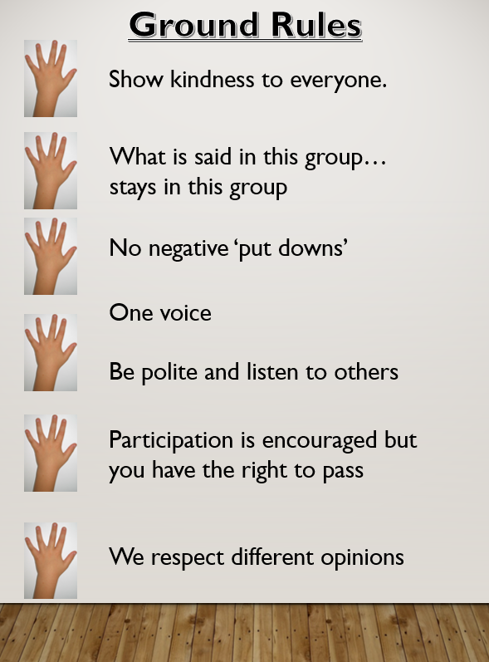
Appendix 4 - PSHE School Curriculum Overview – Also see the Bledlow Ridge PSHE Road Map
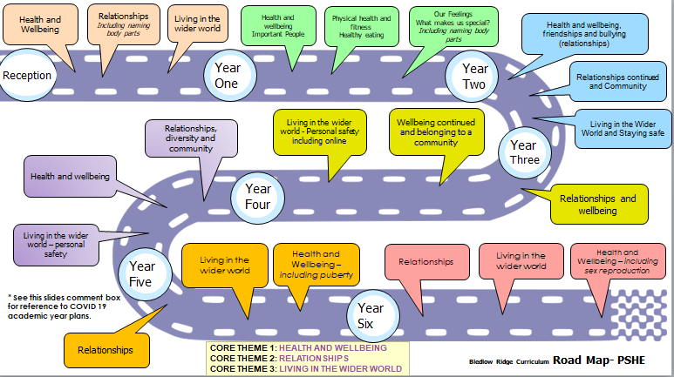

KS1 – Also see the Bledlow Ridge PSHE Road Map for the full list of PSHE statements

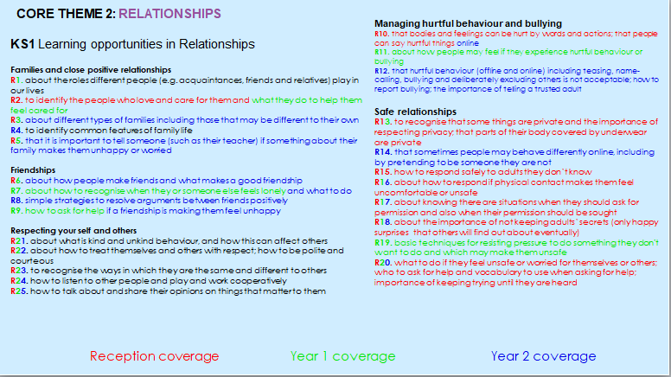

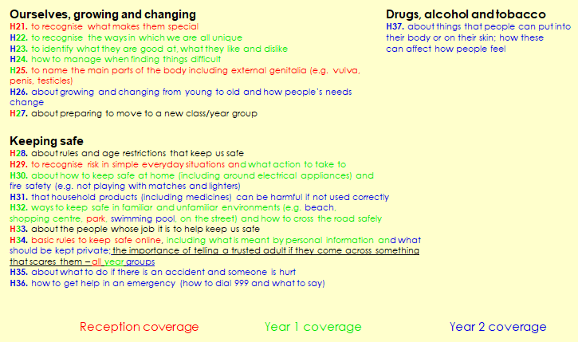
KS2

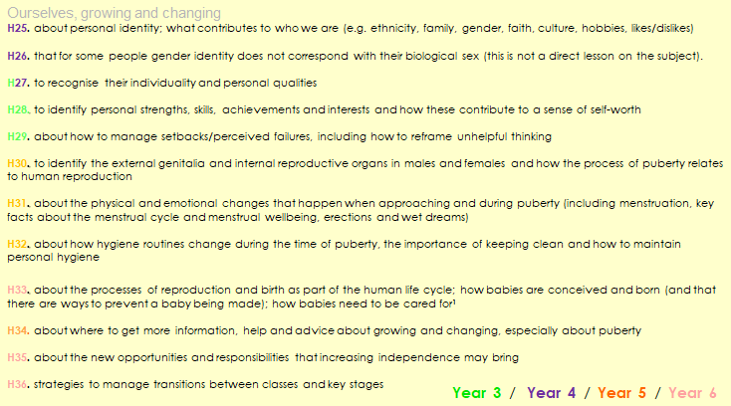

Appendix 5 – Progression and key vocabulary from Year 1 – Year 6 in both science and PSHE
Progression and key vocabulary KS/Year | Science Programme of Study – Statutory requirements |  | Science Programme of Study – Non statutory notes and Guidance |  |  |  | Vocabulary
Year 1 | Pupils should be taught to:  Identify, name, draw and label the basic parts of the human body and say which part of the body is associated with each sense. |  | Pupils should have plenty of opportunities to learn the names of the main body parts (including head, neck, arms, elbows, legs, knees, face, ears, eyes, hair, mouth, teeth) through games, actions, songs and rhymes. |  |  |  | head, neck, arms, elbows, legs, knees, face, ears, eyes, hair, mouth, teeth, penis, testicles, vulva
Year 2 | Pupils should be taught to:  Notice that animals, including humans, have offspring which grow into adults1  Describe the importance for humans of exercise, eating the right amounts of different types of food, and hygiene.  (1‘Growing into adults’ should include reference to baby, toddler, child, teenager, adult) |  | They should also be introduced to the process of reproduction and growth in animals. The focus at this stage should be on helping pupils to recognise growth; they should not be expected to understand how reproduction occurs. The following examples might be used: egg, chick, chicken; egg, caterpillar, pupa, butterfly; spawn, tadpole, frog; lamb, sheep. Growing into adults can include reference to baby, toddler, child, teenager and adult. |  |  |  | baby, toddler, child, teenager, adult
KS/Year | PSHE Association Programme of Study  Core Theme 1: Health and Wellbeing |  |  |  | PSHE Association Programme of Study Core Theme 2: Relationships |  | Vocabulary – see section on Keeping Safe – Vocabulary for further guidance
Key Stage 1 | Pupils should have the opportunity to learn:  5. about change and loss and the associated feelings (including moving home, losing toys, pets or friends, making new friends, new  baby)  8. about the process of growing from young to old and how people’s needs change  9. about growing and changing and new opportunities and responsibilities that increasing independence may bring  10. the names for the main parts of the body (including external genitalia) the similarities and differences between boys and girls |  |  |  | Pupils should have the opportunity to learn:  1. to communicate their feelings to others, to recognise how others show feelings and how to respond  9. to identify their special people (family, friends, carers), what makes them special and how special people should care for one another  10. to judge what kind of physical contact is acceptable, comfortable, unacceptable and uncomfortable and how to respond (including who to tell and how to tell them) |  | Boy, girl, gender, penis, testicles, vulva, pregnant, baby, child, teenager, elderly, life cycle, change,  grow, feelings, love, care, comfortable feeling, uncomfortable feeling
KS/Year | Science Programme of Study – Statutory requirements |  |  |  |  | Science Programme of Study – Non statutory notes and Guidance | Vocabulary
KS2  Year 3 | Pupils should be taught to:  explore the part that flowers play in the life cycle of flowering plants, including pollination, seed formation and seed dispersal. *  * Children should understand that pollination is the movement of pollen from one flower to another and that a seed is formed when material in the pollen joins with material |  |  |  |  |  | Pollination, pollen, male, ovule, female, seed
KS/Year | PSHE Association Programme of Study  Core Theme 1: Health and Wellbeing |  |  |  | PSHE Association Programme of Study Core Theme 2: Relationships |  | Vocabulary - see section on Keeping Safe – Vocabulary for further guidance
KS2 Year 3 Pupils should have the opportunity to learn: | Pupils should have the opportunity to learn:  8. about change, including transitions (between key stages and schools) loss, separation, divorce and bereavement  12. that bacteria and viruses can affect health and that following simple routines can reduce their spread  20. About taking care of their body, understanding that they have autonomy and the right to protect their body from inappropriate and unwanted contact |  |  |  | Pupils should have the opportunity to learn:  2. to recognise what constitutes a positive, healthy relationship and develop the skills to form and maintain positive and healthy relationships  4. to be aware of different types of relationship, including those between acquaintances, friends, relatives and families  8. to judge what kind of physical contact is acceptable or unacceptable and how to respond |  | change, grow, mature, feelings, emotions, excited, up and down,  worried, reproductive organs, sperm, egg
KS/Year |  | Science Programme of Study – Statutory requirements |  | Science Programme of Study – Non statutory notes and Guidance |  |  | Vocabulary
KS2  Year 5 |  | Animals, including humans  Pupils should be taught to:  describe the changes as humans develop to old age  Living things and their habitats  Pupils should be taught to:  describe the differences in the life cycles of a mammal, an amphibian, an insect and a bird  describe the life processes of reproduction in some plants and animals |  | Pupils should draw a timeline to indicate changes in the growth and development of humans. They should learn about the changes experienced in puberty.  Pupils should find out about different types of reproduction, including sexual and asexual reproduction in plants, and sexual reproduction in animals |  |  | gestation period, pregnancy, live birth  sexual reproduction, sperm, ovum, internal fertilisation, external fertilisation, egg, live birth, gestation period
KS/Year |  | PSHE Association Programme of Study  Core Theme 1: Health and Wellbeing |  | PSHE Association Programme of Study Core Theme 2: Relationships |  |  | Vocabulary - see section on Keeping Safe – Vocabulary for further guidance
KS2  Year 4/5 |  | Pupils should have the opportunities to learn:  18. How their body will, and emotions may, change as  they approach and move through puberty  20. About taking care of their body, understanding that they have autonomy and the right to protect their body from inappropriate and unwanted contact |  | Pupils should have the opportunities to learn:  2. to recognise what constitutes a positive, healthy relationship and develop the skills to form and maintain positive and healthy relationships  4. to be aware of different types of relationship, including those between acquaintances, friends, relatives and families  8. to judge what kind of physical contact is acceptable or unacceptable and how to respond |  |  | puberty, change, grow, mature, private parts, genitals, vagina, labia, vulva, clitoris, penis, testicles, breasts, feelings, excited, up and down, attraction, worried, internal, inside, reproductive organs, menstruation, uterus, fallopian tubes, ovary/ovaries, cervix, menstrual cycle, period, blood, discharge, Adam’s apple, penis, testicles, scrotum, sperm, semen, erection, ejaculation, wet dream, masturbation, sweat, body odour, sanitary towel, tampon
Year 6 |  | 18. How their body will, and emotions may, change as they approach and move through puberty  19. about human reproduction  20. About taking care of their body, understanding that they have autonomy and the right to protect their body from inappropriate and unwanted contact |  | 2. to recognise what constitutes a positive, healthy relationship and develop the skills to form and maintain positive and healthy relationships  4. to be aware of different types of relationship, including those between acquaintances, friends, relatives and families  8. to judge what kind of physical contact is acceptable or unacceptable  and how to respond |  |  | puberty, change, grow, mature, private parts, genitals, strong feelings, reproductive organs, menstruation, uterus, fallopian tubes, ovary/ovaries, cervix, vagina, labia, clitoris, vulva, penis, testicles, scrotum, sperm, semen, erection, ejaculation, egg, sexual intercourse, conception, embryo, pregnant, birth, contraception, condom, consent
Source: The Association for Science Education and PSHE Association (March 2016) Joint Policy Statement: Human Development and Reproduction in the Primary Curriculum

Policy development
This policy has been consulted with staff, governors and through an additional readability group of parents and governors for the finalised draft policy.

Suggestions for policy development were
There were no recommendations for amendments or changes to this document.

Miss Claire West – PSHE lead liaised with staff to pull together all relevant information including relevant national and local guidance / guidance from Public Health PSHE lead.

Staff consultation – all school staff were given the opportunity to look at the policy and make recommendations on several occasions throughout March 2020 - March 2021.

Parent/stakeholder consultation – parents and any interested parties were invited to read through our policies and ask questions in regards to anything that they were not clear about.

Pupil consultation – Miss West (PSHE lead) or Mr. Gage (PSHE Governor) have and will continue to seek consultation regarding PSHE lessons and questions raised to shape further lessons. This has been and may in future be achieved through a small focus group who gives their consent to review or answer a questionnaire. In addition to these meetings, teachers will complete a reflective assessment of each terms targets and provide children with the opportunity to review each topic unit once completed throughout the year.

Ratification – this policy was shared and ratified with governors.

This policy was created with the support of Carol Stottor (PSHE Lead for Public Health BCC).

