**Maths – Long Term Plans**

Year 1

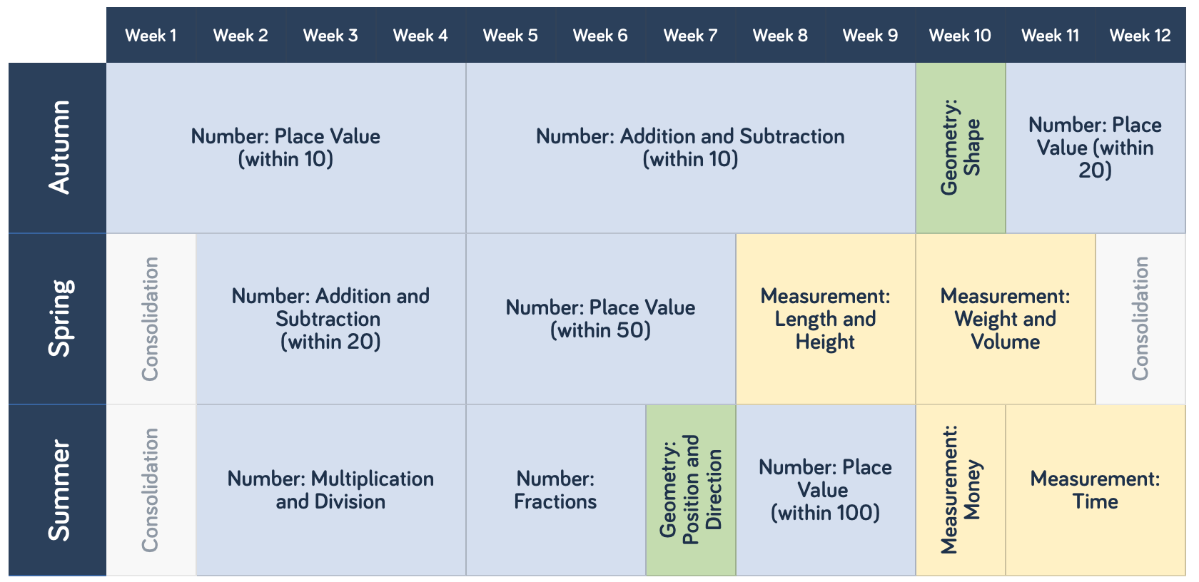

Year 2

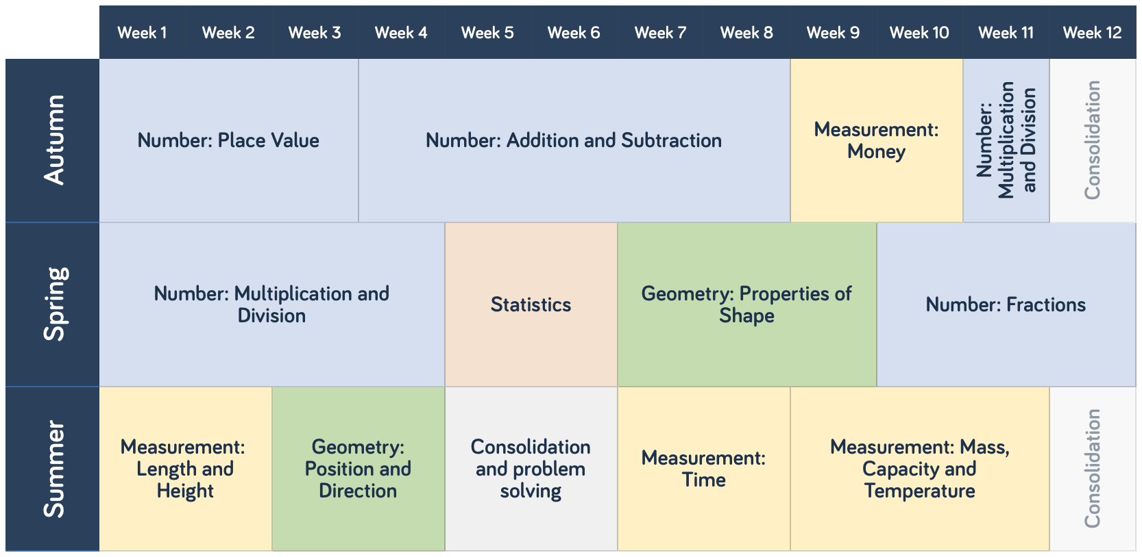

Year 3

Year 4

Year 5

Year 6

