Dear Parent/Carer,
In order to facilitate our remote learning contingency plans I have created a @bledlowridge email address for your child. The details are below:

username
password

This account is an Office365 account, so comes with apps related to such an account. We are not encouraging the children to use it for anything other than accessing Microsoft Teams at this time.

To access Teams, please sign in via the Teams website or via the Teams app, downloadable for the Google Play store or the Apple App Store on mobile or tablet devices. A desktop app is also available. I have found that Safari and the Teams website do not always play nicely together, so I would suggest you use Chrome if you are using the website version. When prompted, type in your username as listed above. This will redirect you to a screen that looks like this (SIMS is our school data management system):
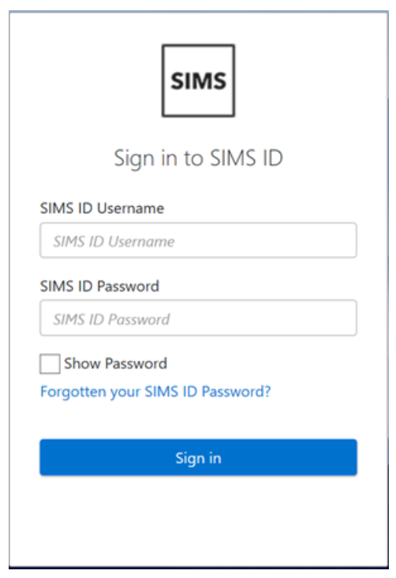
On this screen, please complete the details as requested. This will sign you into the app or website.

When you log on you find will that your child has been added to a Team for their year group and a Whole School Team. The staff should be listed as myself and their class teacher.

Please do not use the chat function at this time, and do not use it to send messages to each other – we will leave that to eSchools for now!

On the left-hand side there is a calendar tab, clicking on this will show any scheduled meetings they have been invited to. At the appropriate time, join this session. Please do not join the session before the allotted start time. For now, I will also send an email message to you as parents when I set up an event. An invite to the any sessions can also be found in the ‘Posts’ section of the Whole School, or class teams. If you add this email account to your phone/calendar you will be able to see any sessions that are added by the class teacher if needed on your calendar.

I have attached our current policy for live sessions to this letter. It is still in draft form and may change. Please take the time to read it carefully and ensure your child understands the behaviour expected of them during a session. If you have any technical problems or questions, do not hesitate to contact me.

Alastair Haywood
Headteacher

